Department Of Computer Engineering
Research & Development
Index

Year |  | 2022 | 2023 | 2024 |  | 2025 | 2026
S.N | Category | Page Number
A | Summary Sheet | 1
B | Year-Wise Documentation Sections | 1
1 | Sci / Wos Publications | 2
2 | Scopus Journal Articles | 3 | 3 |  | 4 | 4 | 5
3 | Scopus Conference Papers | - | 6 |  | 6 | 4 | 8
4 | Scopus Book / Book Chapters | 9 | 9 |  | 9 | 10 | 11
5 | Patents | 12
6 | Funded Research Projects | - | - |  | - | - | -
7 | Consultancy Projects | 14-16
8 | Research Mous | - | - |  | - | - | -
9 | International Conferences Organized | - | - |  | - | - | -
C | Staff Wise Scopus Profile | 17-68
D | Staff Wise Google Scholar Profile | 68-69
1 | UGC Papers | 69-79

Scan Qr To Get The Details



Overall Summary Sheet (2022 – Till Date)

Sr. No. | Research Category | 2022 | 2023 | 2024 | 2025 | 2026 | Total
1 | Sci / Wos Publications |  |  |  | 1 |  | 1
2 | Scopus Journal Articles | 1 | 3 | 4 | 1 | 2 | 11
3 | Scopus Conference Papers |  | 4 | 2 | 4 | 6 | 16
4 | Scopus Books/ Chapters | 1 | 2 | 5 | - | 1 | 10
5 | Patents | 2 | 1 | 6 |  |  | 9
6 | Funded Research Projects | 0 | 0 | 0 | 0 | 0
7 | Consultancy Projects | 0 | 0 | 0 | 2 | 0
8 | Research Mous | 0 | 0 | 0 | 0 | 0 | 0
9 | International Conferences Organized | 0 | 0 | 0 | 0 | 0 | 0
10 | Ugc | 12 | 50 | 118 | 109 | 6 | 296

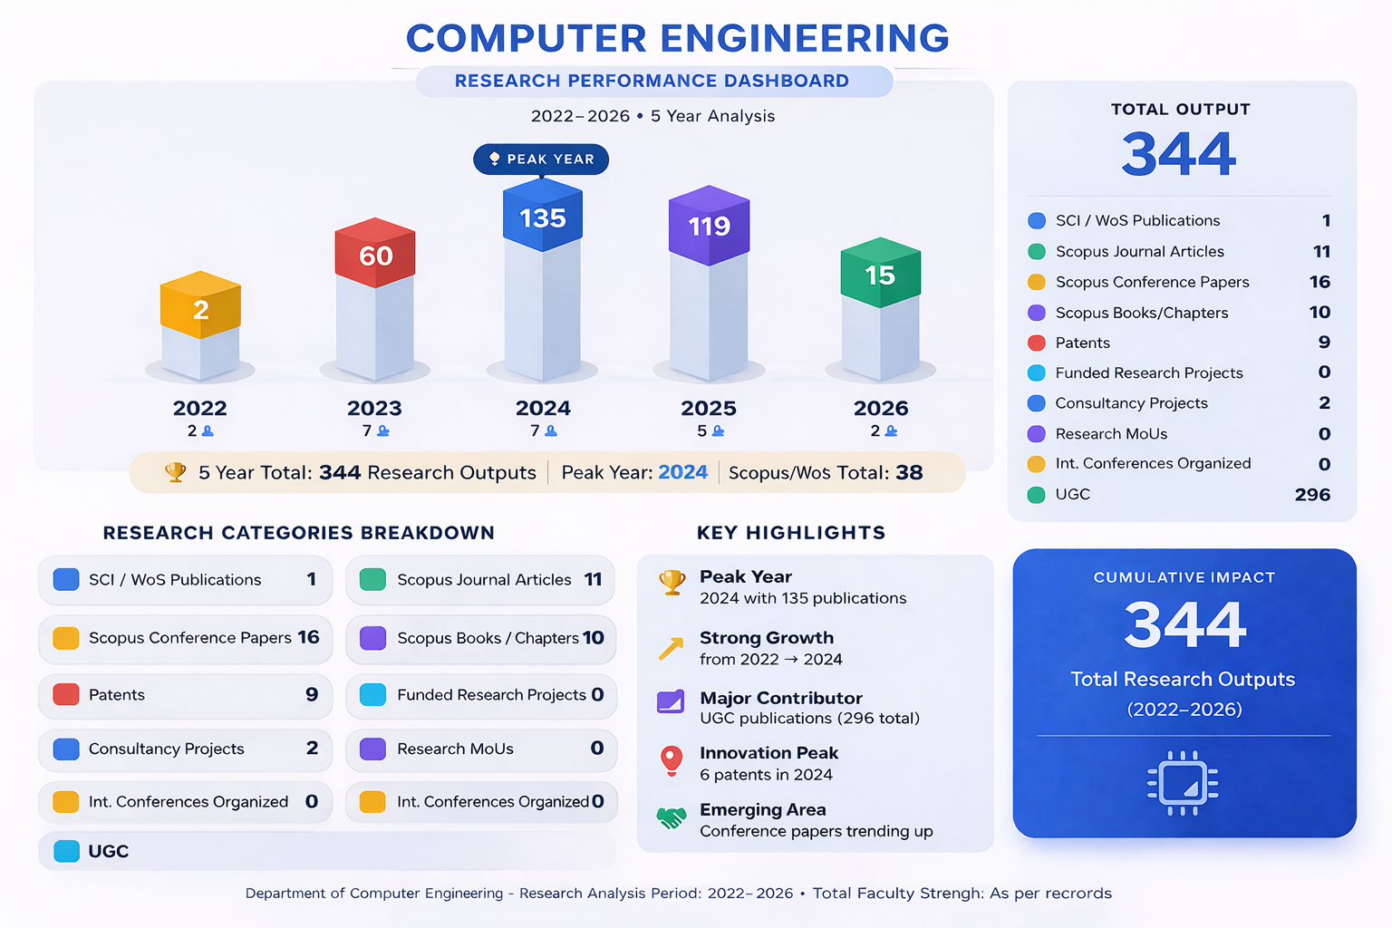
B.1. Sci / Wos Publications

Year | Faculty | Authors | Title | Name Of  Journal
2026 | Dr. Renuka S.Gound | Gound R.S.; Mujawar F.; Dhakulkar N.; Rathod P.; Bhise S.; Moholkar K. | The Virtual Healing Garden | Lecture Notes In Networks And Systems

2_Scopus Journal Article

2022
Name Of Faculty | Author Full Names | Title | Journal Title
Dr.Chandrakant Kokane | Kokane, Chandrakant (57223105704); Babar, Sachin (36536541300); Mahalle, Parikshit (35170655700); Patil, Shivprasad (57197765213) | Word Sense Disambiguation: A Supervised Semantic Similarity Based Complex Network Approach | International Journal Of Intelligent Systems And Applications In Engineering

2023
Name Of Faculty | Author Full Names | Title | Journal Title
Dr.Chandrakant Kokane | Kokane, Chandrakant D. (57223105704); Babar, Sachin D. (36536541300); Mahalle, Parikshit N. (35170655700); Patil, Shivprasad P. (57197765213) | Word Sense Disambiguation: Mathematical Modelling Of Adaptive Word Embedding Technique For Word Vector | Journal Of Interdisciplinary Mathematics
Dr.Chandrakant Kokane, Prof. Tushar Waykole | Kokane, Chandrakant D. (57223105704); Mohadikar, Gopal (58583335300); Khapekar, Sonu (58581148200); Jadhao, Bharti (58583790000); Waykole, Tushar (58582021300); Deotare, Vilas V. (55786300000) | Machine Learning Approach For Intelligent Transport System In Iov-Based Vehicular Network Traffic For Smart Cities | International Journal Of Intelligent Systems And Applications In Engineering
Dr.Chandrakant Kokane | Kokane, Chandrakant Deelip (57223105704); Pathak, Kishor R. (58581146900); Mohadikar, Gopal (58583335300); Pagar, Rakhi Subhash (58879166500); Chavan, Suhas (58879796700); Kshirsagar, Sopan Bapu (58785492000) | Unraveling The Complexity With Applications Of Nonlinear Analysis In Signal Processing And Communication Engineering | Advances In Nonlinear Variational Inequalities

2024
Name Of Faculty | Author Full Names | Title | Journal Title
Prof.Pritam Ahire | Sarode, Ghanasham C. (59251257700); Chaudhari, Rahul S. (58507886800); Siraskar, Gulab (35316228000); Ahire, Himanshu (59408555800); Pawar, Shantanu (57577317100); Shinde, Nitin (57425610000); Dhore, Prasad Baban (59218660900); Sarode, Deepika G. (59250947600) | Assessment Of Bitumen Paver And Hmp Efficiency For A Road Project | Panamerican Mathematical Journal
Prof. Rohini Hanchate | Hanchate, Rohini (58172149600); Anandan, R. (55418360900) | Medical Image Encryption Using Hybrid Adaptive Elliptic Curve Cryptography And Logistic Map-Based Dna Sequence In Iot Environment | Iete Journal Of Research
Dr,Saurabh Saoji | Jayakumar, Naveenkumar (57191282068); Saoji, Saurabh (56208866300); Joshi, Sagar V. (57208663010); Mane, Hemlata (59320386900); Narkhede, Roshni (59320529500); Jadhav, Shrikant (57192978756) | Enhancing Diagnostic Accuracy: A Hybrid Approach To Mitigate Speckle And Rician Noise In Medical Images | Advances In Nonlinear Variational Inequalities
Prof Prachi Waghmare  Prof. Chaudhari Dipamala | Charkha, Sarita (58899123900); Jakhete, Mayur (57205023291); Waghmare, Prachi (58633483400); Chaudhari, Dipamala (58906415000); Jatale, Ketan (58905717300); Zope, Tejaswini (58066643400); Rathi, Bhushan (58906068900); Sharma, Vidur (58906415100) | Advancements In Cyclostationary Technique For Cognitive Radio: An In-Depth Examination And Evaluation | International Journal Of Intelligent Systems And Applications In Engineering

2025
Name Of Faculty | Author Full Names | Title | Journal Title
Dr.Priyanka Halle | Mukhedkar, Moresh Madhukar (57190403074); Jadhav, Vaishali Satish (57210705430); Halle, Priyanka Dhondiraj (57210697177); Waghmode, Uttam Popat (58305270800); Dawande, Nitin Ashok (56891451000); Sapkale, Pallavi Vasant (57203619387) | Routing And Trust Management In Manet Using Hybrid Crayfish White Shark Optimisation | International Journal Of Wireless And Mobile Computing

2026

Name Of Faculty | Author Full Names | Title | Journal Title
Prof. Pritam Ahire | Ahire, Pritam Ramesh (59579134100); Priya, K. Ulaga (57193138759) | Predictive Modelling And Healthcare Monitoring System Using Enhanced Variational Auto Encoder Model | Ksii Transactions On Internet And Information Systems
Dr.Renuka Gound | Gound, Renuka Sandeep (57210411110); Thepade, Sudeep D. (24829931300) | Sensenet: Satellite Image Enhancement Using Optimised Deep Denoiser For Cloud Removal | International Journal Of Bio-Inspired Computation

B.3_Scopus Conference Papers

2023
Name Of Faculty | Author Full Names | Title | Journal Title
Dr.Saurabh Saoji | Lal, Mily (58097448600); Bhende, Manisha (57212697259); Goel, Akanksha (58068324300); Tamrakar, Poi (58975760600); Saoji, Saurabh (56208866300) | A Hybrid Deep Learning Approach For Sentiment Analysis Of Dementia Care | 2023 Ieee Engineering Informatics, Ei 2023
Prof.Rohini Hanchate | Pagale, Madhuri (58313090800); Mulik, Sunanda (58313293000); Purohit, Richa (58312694100); Thakare, Anuradha (55995624200); Hanchate, Rohini (58172149600); Jadhav, Sulaxan (58314080900) | Design And Implementation Of Lane Detection Using Hough Transformation | Proceedings Of The 2nd International Conference On Applied Artificial Intelligence And Computing, Icaaic 2023
Prof.Tushar Waykole | Wankhede, D.S. (57220890077); Kalra, Nuvita (58637260400); Dhabliya, Ritika (57216437768); Khetani, Vinit (57220893453); Waykole, Tushar (58582021300); Shirkande, Aparna S. (59144348600) | Enhancing Alzheimer's Disease Prediction With Bayesian Optimization And Ensemble Methods | Acm International Conference Proceeding Series
Prof.Sirsat S.D. | Dhabliya, Dharmesh (57222241738); Borade, Monali Ravindra (58783321500); Rizvi, Nuzhat Fatima (59454914700); Dhablia, Anishkumar (57956631000); Ghonge, Vilas D. (59144016900); Sirsat, Satyajit Dnyandev (59143858600) | Utilizing Data Mining Techniques To Develop Accurate Predictive Models For Cardiovascular Disease Risk Assessment And Early Detection | Acm International Conference Proceeding Series

2024
Name Of Faculty | Author Full Names | Title | Journal Title
Dr.Saurabh Saoji | Goel, Akanksha (58068324300); Tamrakar, Poi (58975760600); Lal, Mily (58097448600); Bhende, Manisha (57212697259); Wani, Minal (55893262600); Saoji, Saurabh (56208866300) | Real-Time Medical Iot For Continuous Glucose Monitoring | 2024 International Conference On Intelligent Systems And Advanced Applications, Icisaa 2024
Dr.Saurabh Saoji | Lal, Mily (58097448600); Neduncheliyan, S. (17435408500); Goel, Akanksha (58068324300); Tamrakar, Poi (58975760600); Saoji, Saurabh (56208866300); Bhende, Manisha (57212697259) | Healthcare Interaction Through Conversational Ai | 2nd Ieee International Conference On Integrated Intelligence And Communication Systems, Iciics 2024

2025
Name Of Faculty | Author Full Names | Title | Journal Title
Dr. Prasad Dhore | Dhore, P.B. (59218660900); Patil, Uma (59373779000); Shinde, P.S. (59712899400) | Faculty And Student Perceptions Of Library Resource And Service Utilization: A Clustering Algorithm Approach | Cognitive Science And Technology
Prof. Tushar Waykole | Soni, Monika (59144035700); Pawar, Avinash M. (59231132400); Khubalkar, Deepti (58025412800); Tanjeja, Ankit Kumar (59726716800); Mishra, V.A. (7102563583); Waykole, Tushar Satish (58582021300) | A Novel Nsga-Ii Approaches For Combating Advanced Persistent Threats With Machine Learning | Smart Innovation, Systems And Technologies
Dr. Renuka Gound | Ghogare, Snehal (59465036600); Dhupe, Shivkanya (59465200600); Kulkarni, Abhijit (59464875100); Shingane, Tanish (59465363500); Gound, Renuka (57210411110) | Plantcare Ai: An Ai Based Solution For Plant Disease Diagnosis And Assistance | 6th International Conference On Mobile Computing And Sustainable Informatics, Icmcsi 2025 - Proceedings
Dr. Halle Priyanka | Rani, M. (60145372800); Arul Mary Rexy, V. (58934551300); Halle, Priyanka D (57210697177); Kaushal, Jyoti (59385275600); Chauhan, Amit (55516713700); Basha, H. Anwer (57209257136) | A Systematic Approach For Predicting Cybersecurity Attacks In Iot Using Cnn-Lstm With Habcabo | 3rd Ieee International Conference On Data Science And Network Security, Icdsns 2025

2026
Name Of Faculty | Author Full Names |  | Title | Journal Title |  | Author Full Names
Dr. Renuka Gound | Gound, Renuka Sandeep (57210411110); Mujawar, Farhan (60162384800); Dhakulkar, Niraj (60162412600); Rathod, Payal (60162306600); Bhise, Saish (60162384900); Moholkar, Kavita (57202970293) |  | The Virtual Healing Garden | Lecture Notes In Networks And Systems
Dr.Prasad Dhore |  | Dhore, P.B. (59218660900); Patil, Uma (59373779000); Shinde, P.S. (59712899400) | Faculty And Student Perceptions Of Library Resource And Service Utilization: A Clustering Algorithm Approach | Cognitive Science And Technology
Prof. Tushar Waykole |  | Soni, Monika (59144035700); Pawar, Avinash M. (59231132400); Khubalkar, Deepti (58025412800); Tanjeja, Ankit Kumar (59726716800); Mishra, V.A. (7102563583); Waykole, Tushar Satish (58582021300) | A Novel Nsga-Ii Approaches For Combating Advanced Persistent Threats With Machine Learning | Smart Innovation, Systems And Technologies
Dr. Renuka Gound |  | Ghogare, Snehal (59465036600); Dhupe, Shivkanya (59465200600); Kulkarni, Abhijit (59464875100); Shingane, Tanish (59465363500); Gound, Renuka (57210411110) | Plantcare Ai: An Ai Based Solution For Plant Disease Diagnosis And Assistance | 6th International Conference On Mobile Computing And Sustainable Informatics, Icmcsi 2025 – Proceedings
Dr.Priyanka Halle. |  | Rani, M. (60145372800); Arul Mary Rexy, V. (58934551300); Halle, Priyanka D (57210697177); Kaushal, Jyoti (59385275600); Chauhan, Amit (55516713700); Basha, H. Anwer (57209257136) | A Systematic Approach For Predicting Cybersecurity Attacks In Iot Using Cnn-Lstm With Habcabo | 3rd Ieee International Conference On Data Science And Network Security, Icdsns 2025
Dr. Renuka Gound |  | Gound, Renuka Sandeep (57210411110); Mujawar, Farhan (60162384800); Dhakulkar, Niraj (60162412600); Rathod, Payal (60162306600); Bhise, Saish (60162384900); Moholkar, Kavita (57202970293) | The Virtual Healing Garden | Lecture Notes In Networks And Systems

B.4_ Scopus Book / Book Chapters
2022
Name Of Faculty | Author Full Names | Title | Source Title
Prof.Pritam Ahire | Ahire, Pritam R. (59579134100); Hanchate, Rohini (58172149600) | Predictive And Descriptive Analysis For Healthcare Data | Handbook Of Intelligent Healthcare Analytics: Knowledge Engineering With Big Data Analytics
2023

Name Of Faculty | Author Full Names | Title | Source Title
Prof.Pritam Ahire | Ahire, Pritam R. (59579134100); Hanchate, Rohini (58172149600); Varadarajan, Vijayakumar (57314747500) | Indigenous Knowledge In Smart Agriculture | Advanced Technologies For Smart Agriculture
Dr.Chandrakant kokane | Kokane, Chandrakant (57223105704); Babar, Sachin (36536541300); Mahalle, Parikshit (35170655700) | An Adaptive Algorithm For Polysemous Words In Natural Language Processing | Lecture Notes In Networks And Systems

2024
Name Of Faculty | Author Full Names | Title | Source Title
Dr.Saurabh Saoji | Jayakumar, Naveenkumar (57191282068); Prasanth, Narayanan (26428317700); Joshva Devadas, T. (55353687300); Krishnan, Saravanan (59251097000); Saoji, Saurabh (56208866300); Jadhav, Shrikant (57192978756) | Blockchain Empowered Digital Twins: A Comprehensive Review Of Integration And Innovation | Handbook Of Industrial And Business Applications With Digital Twins
Prof.Pritam Ahire | Ahire, Pritam Ramesh (59579134100); Hanchate, Rohini (58172149600); Kalaiselvi, K. (58566282100) | Optimized Data Retrieval And Data Storage For Healthcare Applications | Predictive Data Modelling For Biomedical Data And Imaging
Prof.Pritam Ahire | Hanchate, Rohini Sheetalkumar (58172149600); Ahire, Pritam Ramesh (59579134100) | An Augmented Reality-Based, Personalized Healthcare Management System Using Blockchain Technology | Modern Technology In Healthcare And Medical Education: Blockchain, Iot, Ar, And Vr
Dr.Chandrakant Kokane | Kokane, Chandrakant D. (57223105704); Khandagale, Pranav (59150739700); Ligade, Mehul (59150547300); Garde, Shreeyash (59150644200); Deotare, Vilas (55786300000) | Data-Centric Ai Approaches For Machine Translation | Data-Centric Artificial Intelligence For Multidisciplinary Applications
Prof Tushar Waykole | Singh, Shivam (59150263100); Kokane, Chandrakant D. (57223105704); Deotare, Vilas (55786300000); Waykole, Tushar (58582021300) | Machine-Learning Techniques For Effective Text Mining | Data-Centric Artificial Intelligence For Multidisciplinary Applications

2026
Authors | Author Full Names | Title | Source Title
Dr.Gound R.S. | Gound, Renuka Sandeep (57210411110); Mujawar, Farhan (60162384800); Dhakulkar, Niraj (60162412600); Rathod, Payal (60162306600); Bhise, Saish (60162384900); Moholkar, Kavita (57202970293) | The Virtual Healing Garden | Lecture Notes In Networks And Systems

B.5_ Patents
Applicant Name | Title Of Invention | Application Number | Publication Date
Prof. Pritam Ahire & Prof Rohini Hanchate | Artifi Cial Intelligence Based Smart Accident Detection Through Videosurveillance Using Computer Vision And Deep Learning Algorithms | 202241036175 | 22-07-2022
Prof. Pritam Ahire, Dr. Saurabh Saoji & Prof Rohini Hanchate | Soil Condition Sensing Using Pico Hydroelectric Generation | 202321035298 | 23-06-2023
Prof.Dipamala Chaudhari  Prachi Waghmare | Artifical Intelligence Based Urban Sewage Management System With Real Time Monitoring And Damage Repairing | 202321084969 | 19-01-2024
Prof.Pritam Ramesh Ahire | Brain-Computer Interface Device | 420541-001 | 11-09-2024
Prof.Dipamala Chaudhari |  | 427914-001 | 04-10-2024
Prof.Dipamala Chaudhari | Compact Health Monitoring Device | 202421079556 | 22-11-2024
Prof.Sonu Khapekar  Prof.Shital Jade  Prof. Yogesh Shepal | Wearable Health Monitoring Device | 441133-001 | 18-12-2024
Prof.Rohini Hanchate, Prof.Pritam Ramesh Ahire | Automatic Safe Heath Care System For Prediction, Prevention And Diagnosis Of All Heart Related Diseases At Early Stage Using Deep Learning, Artiﬁcial Intelligence And Data Mining Techniques | 202241036599 | 01/07/2022
Prof.Rohini Hanchate, Prof.Pritam Ramesh Ahire | Innovative Secure Communication In Smart Homes: Integrating Blockchain And Machine Learning Technologies | 202441001763 | 09/02/2024
Prof.Renuka Kajale  Prof.Smita Thube | Signal Traffic Management System. (Granted)
Prof. Smita Thube | Industrial Robotics Control Interface Display | 441132-001

B.6_Consultancy Projects

Sr. No. | Project Name | Industry Name | Amount
1 | Synergyboard: Intelligent Collaboration Tool For Management Review Meetingd | Mask Polymer Pvt. Ltd. | 522000
2 | Kaizen Report Generator | Mask Polymer Pvt. Ltd. | 535000
Total: |  |  | 1057000

Consultancy Project Details

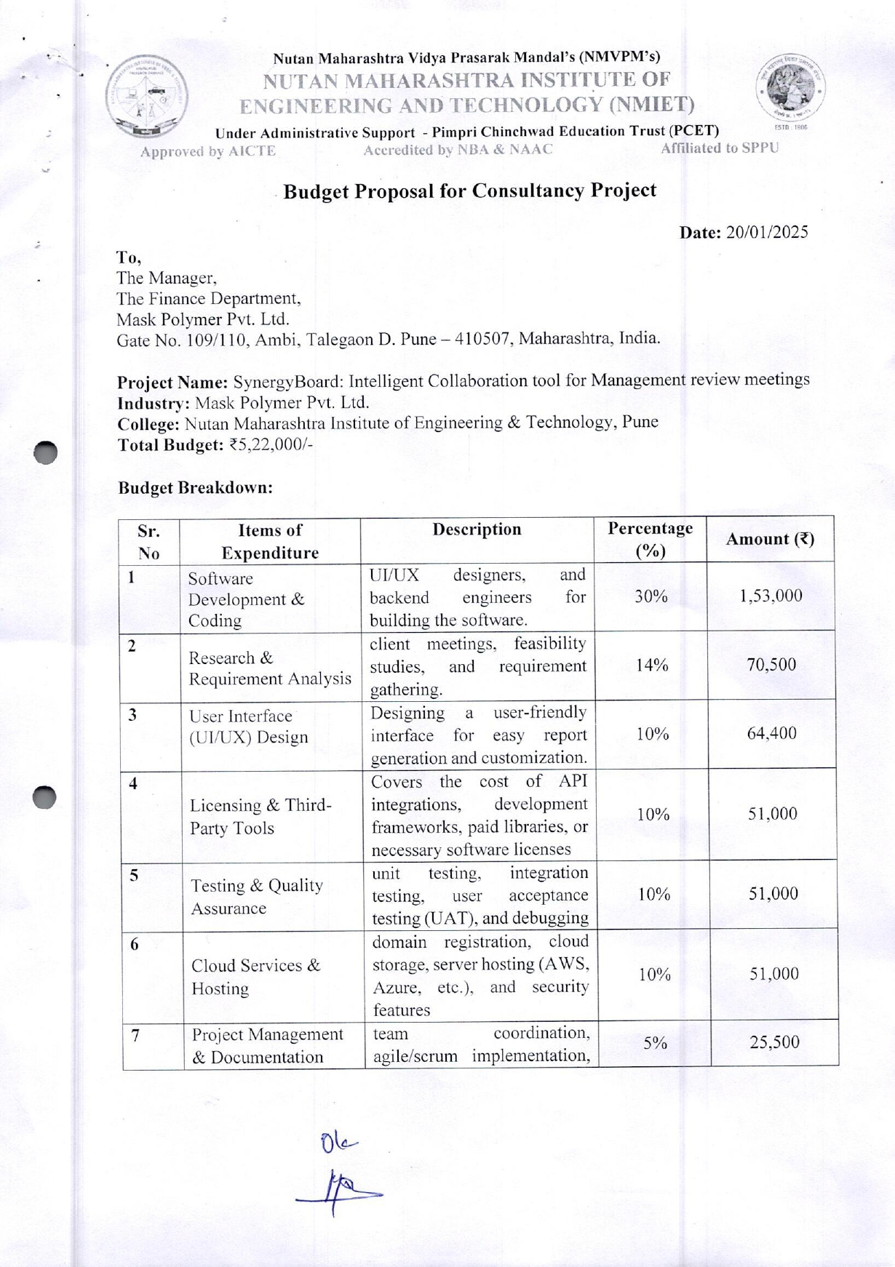

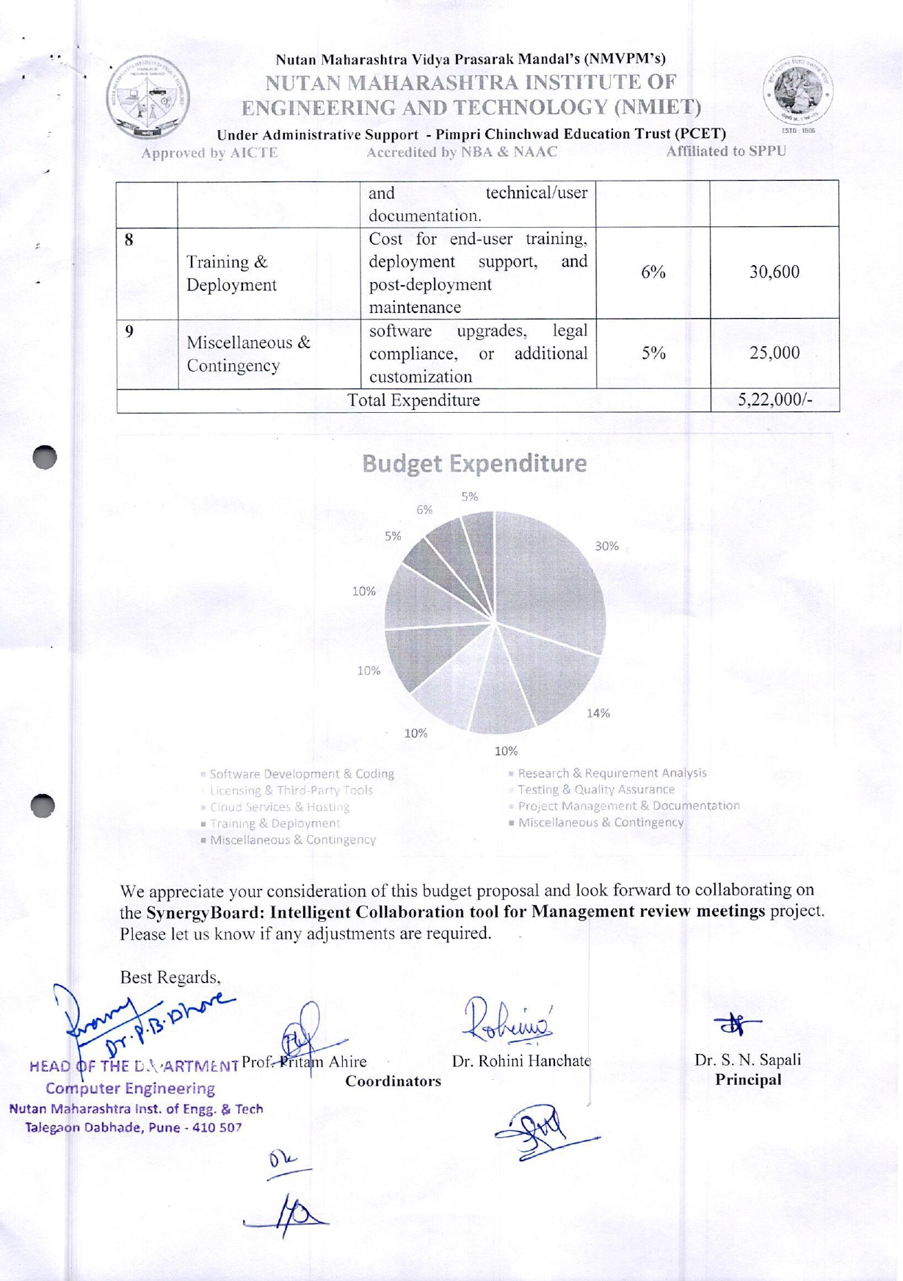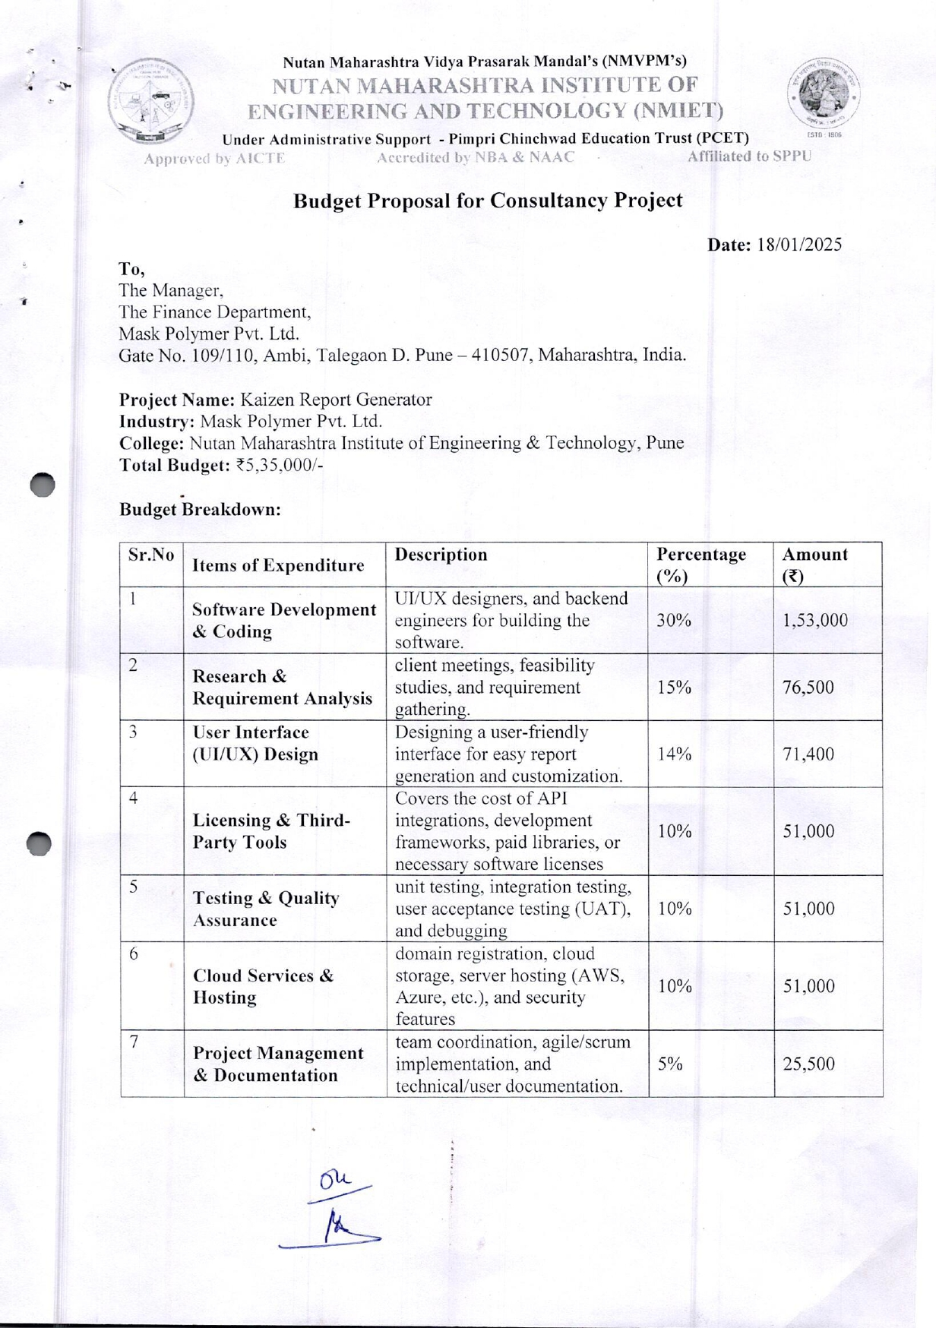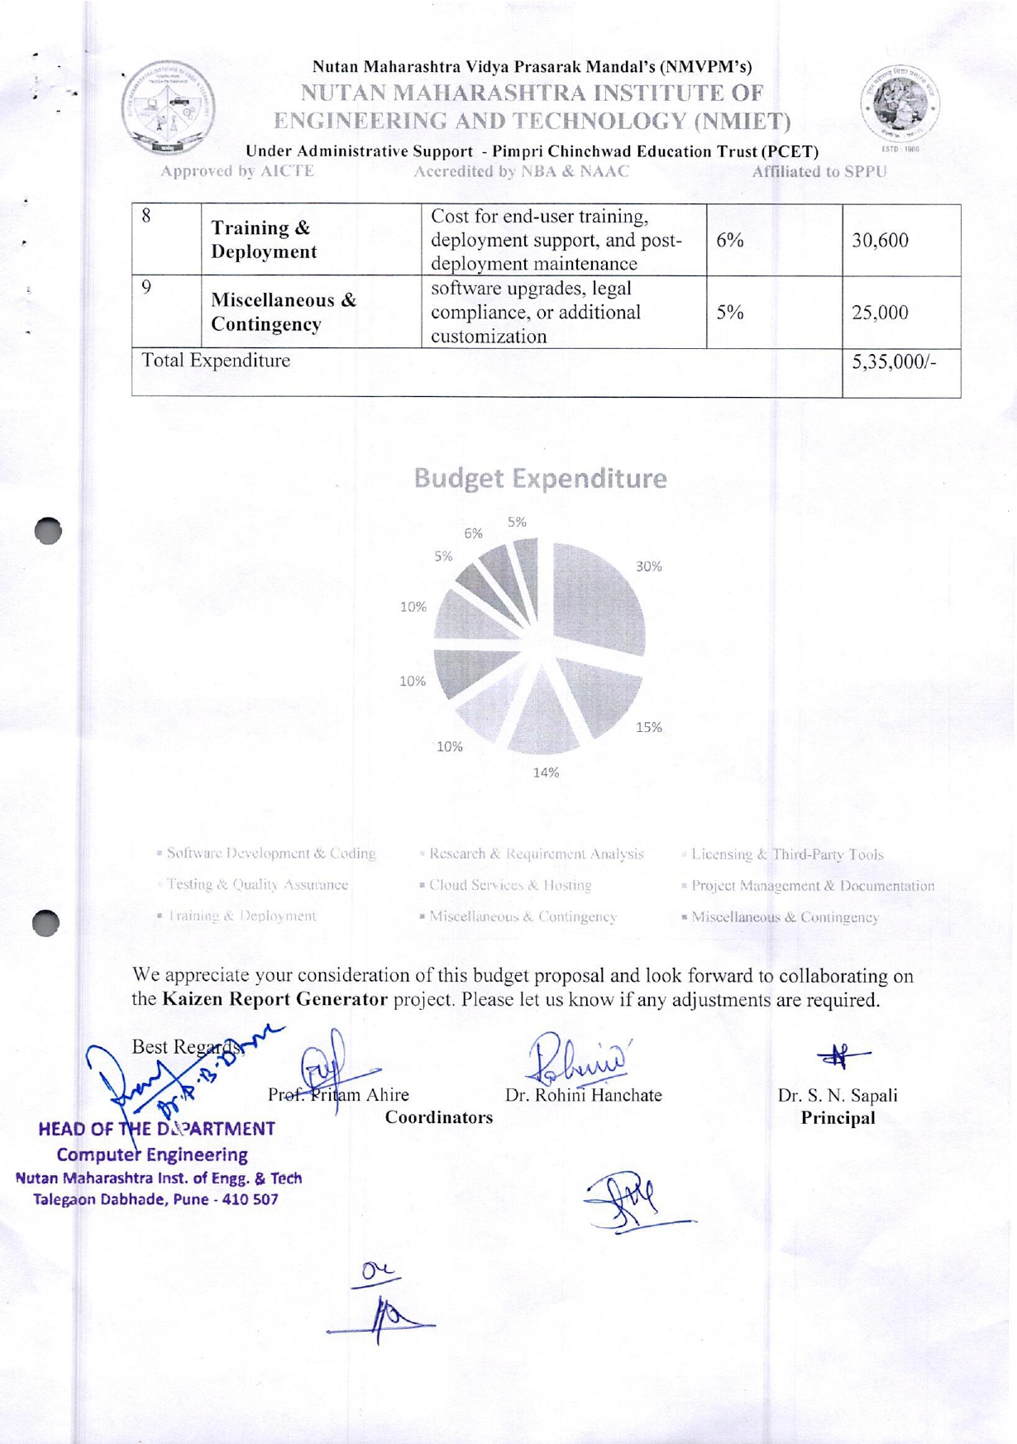

Staff Scopus Profile

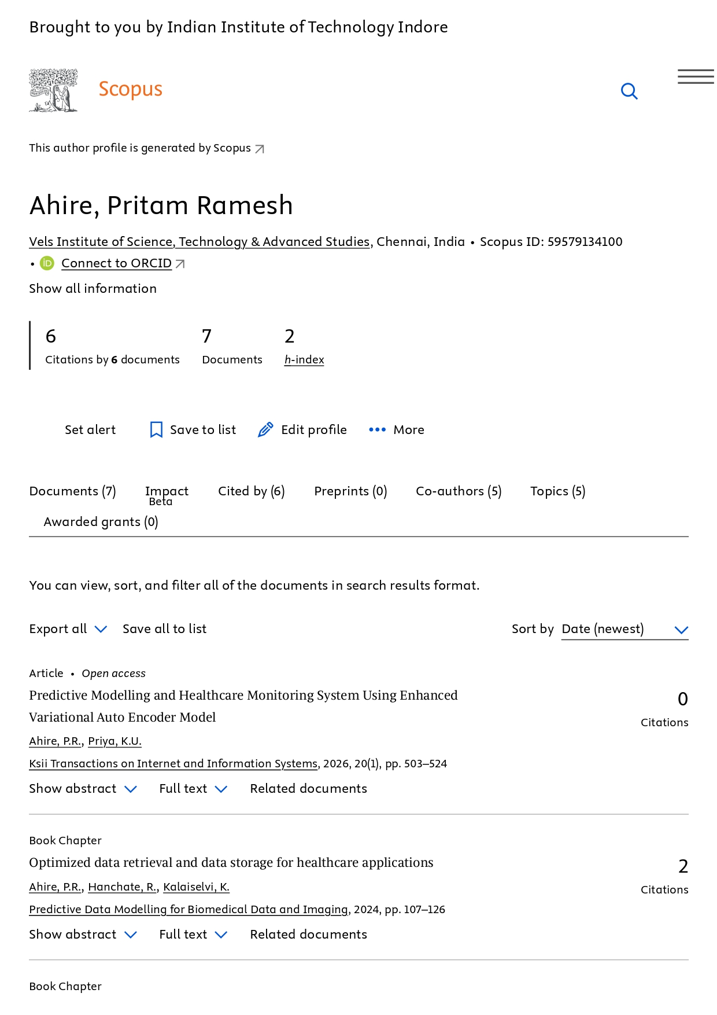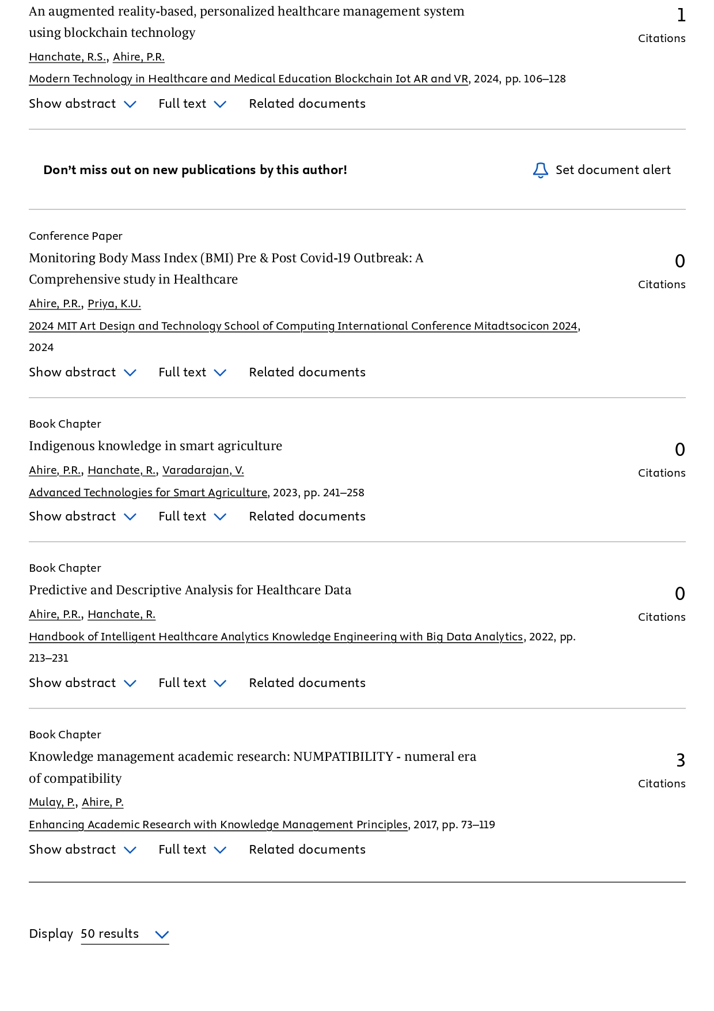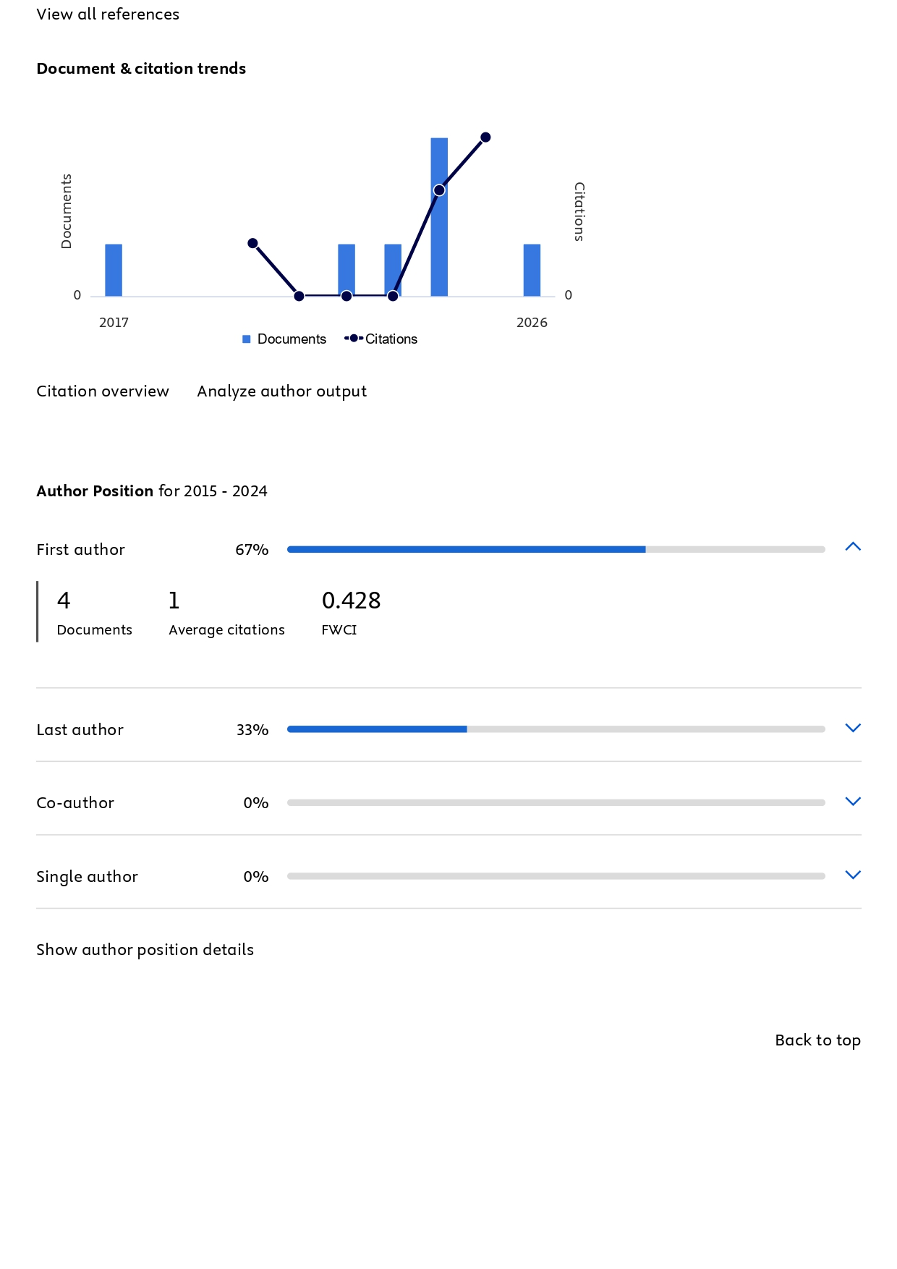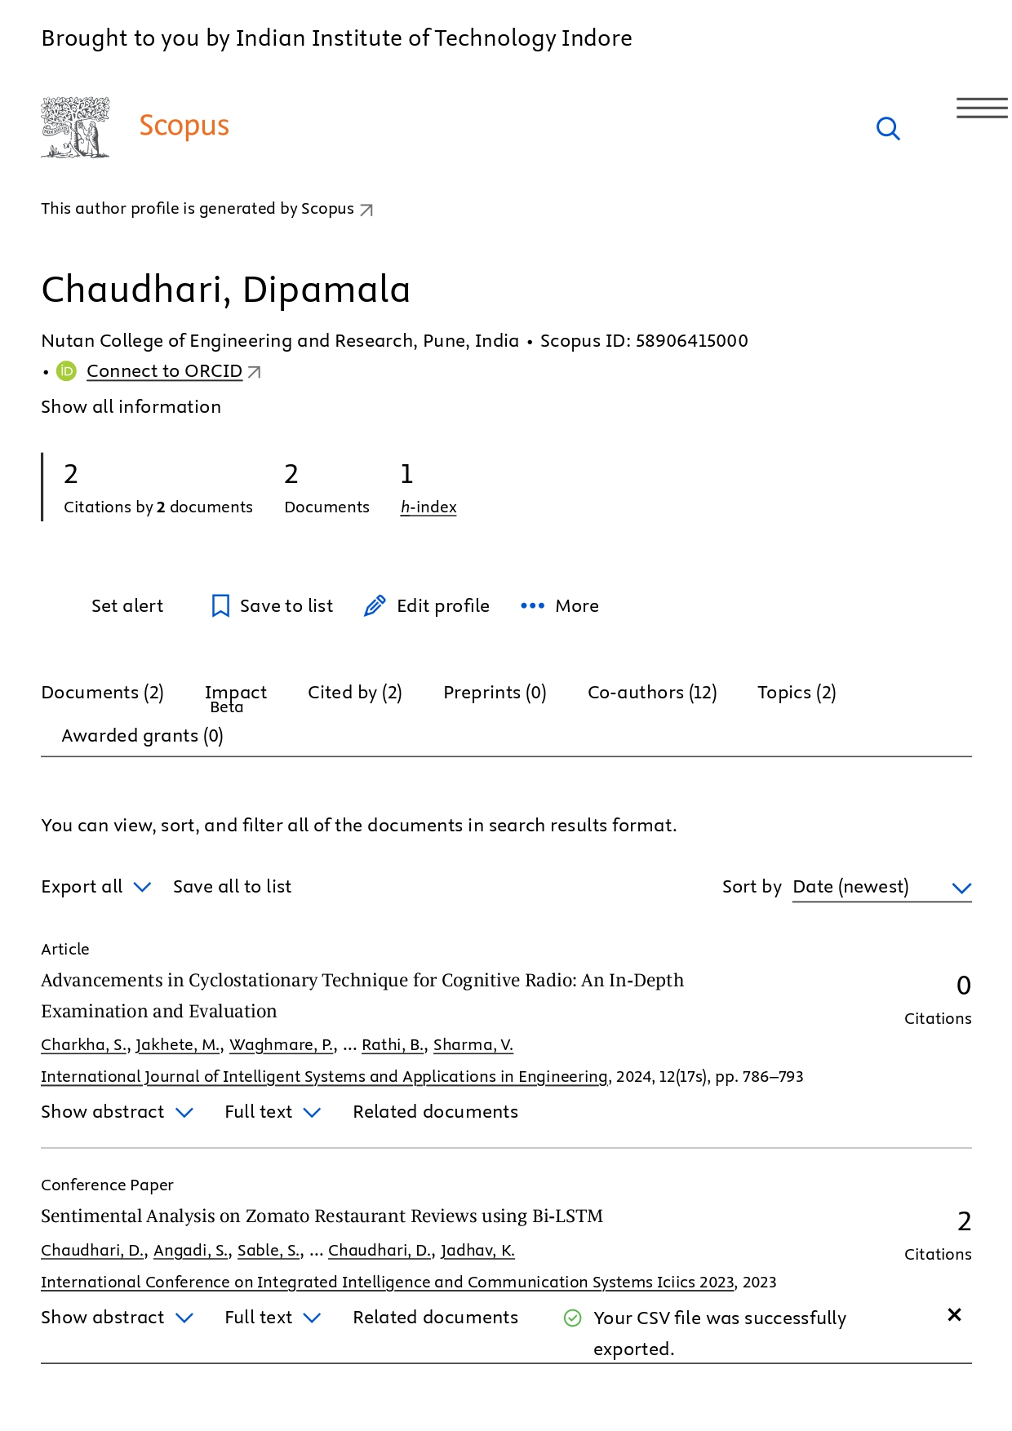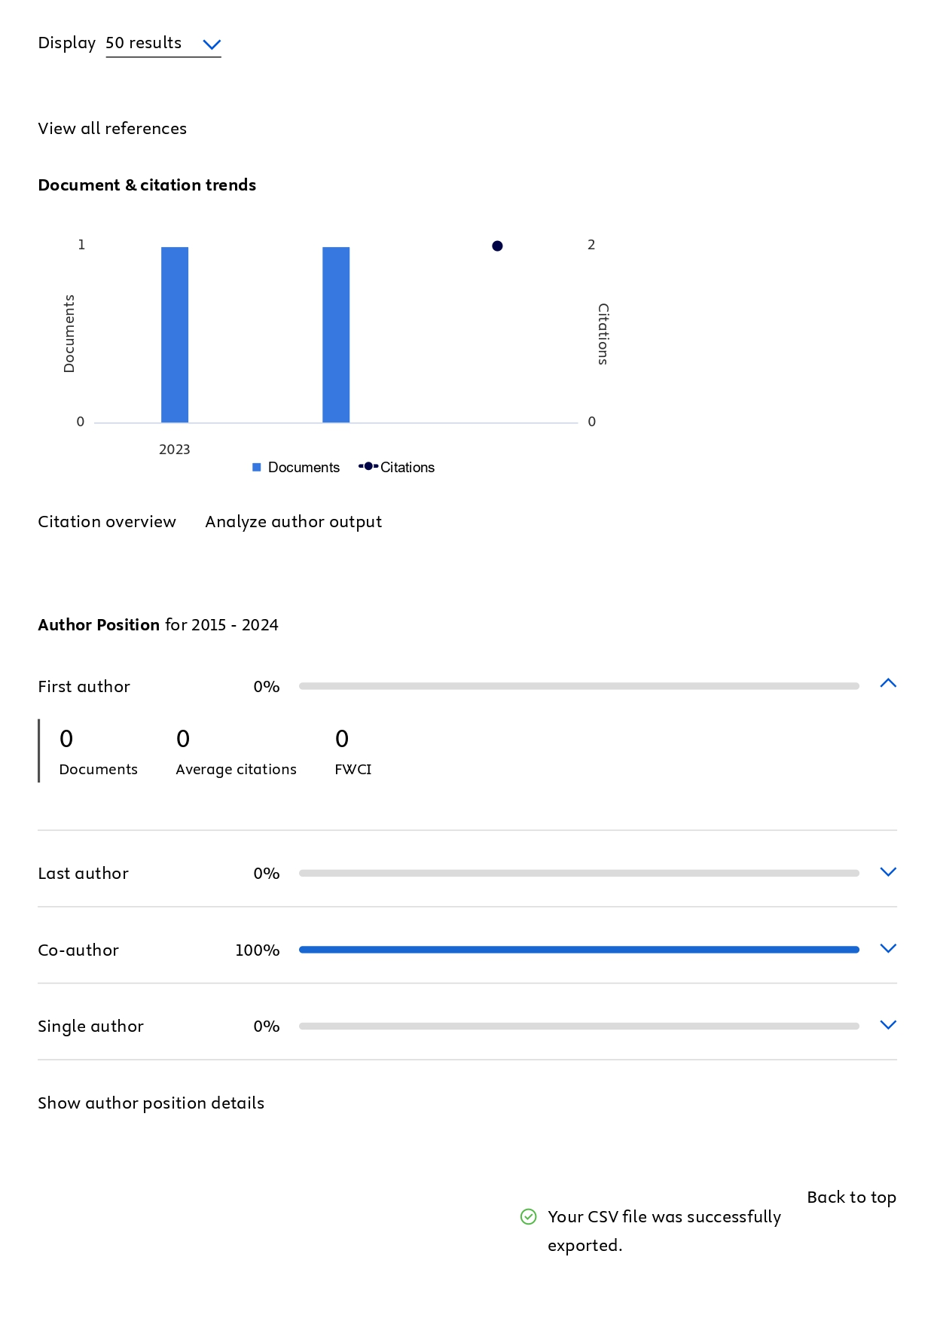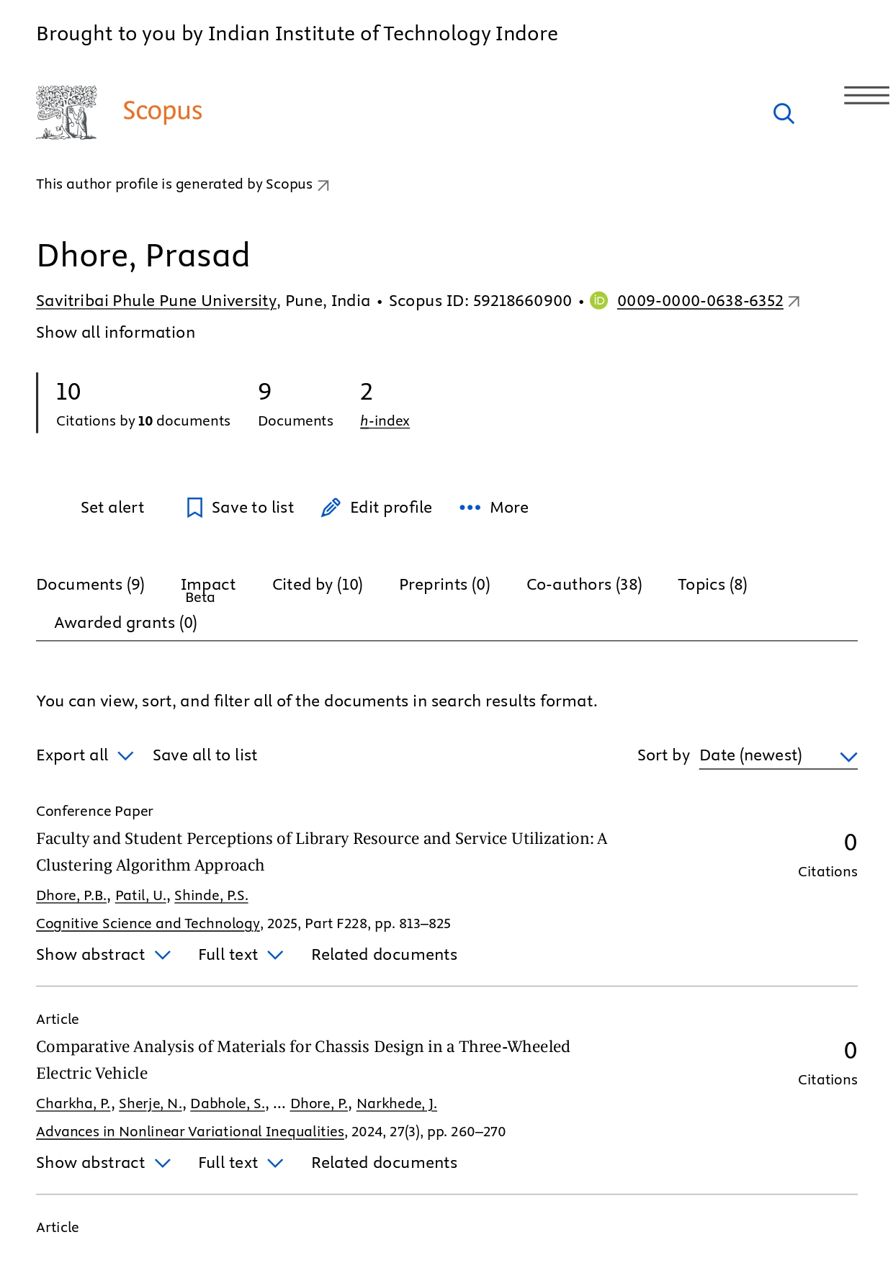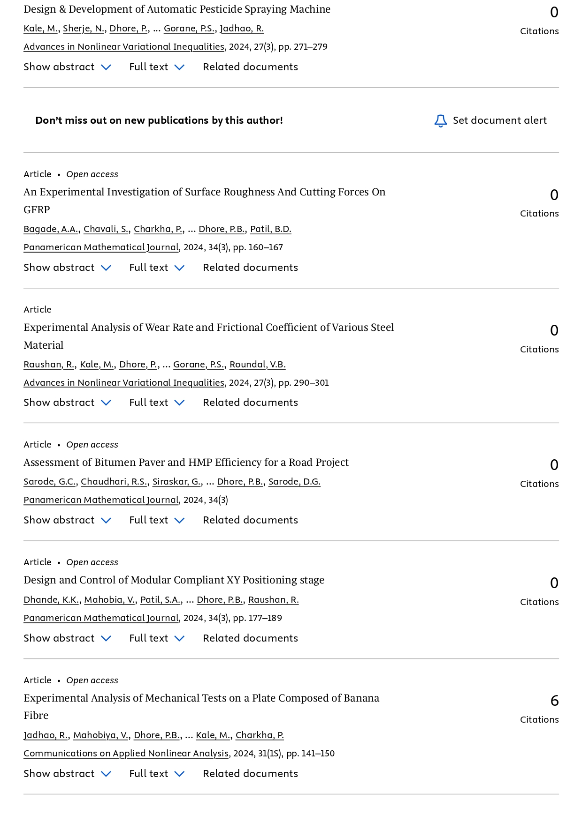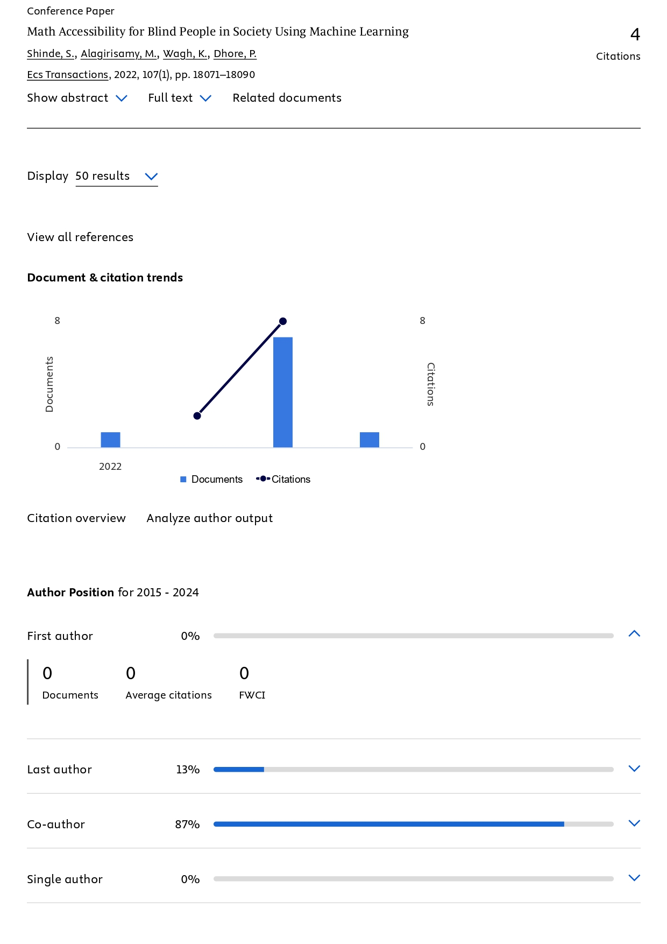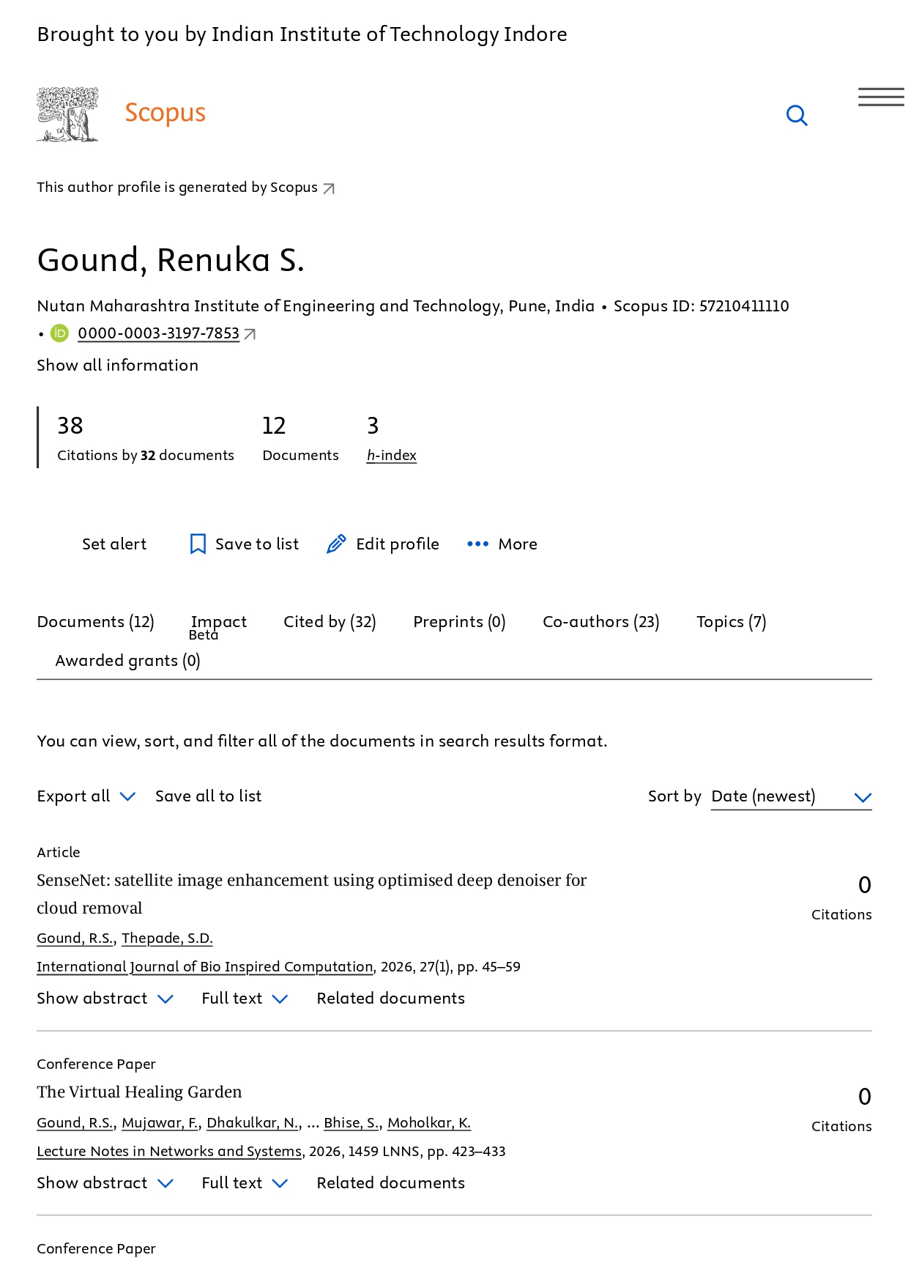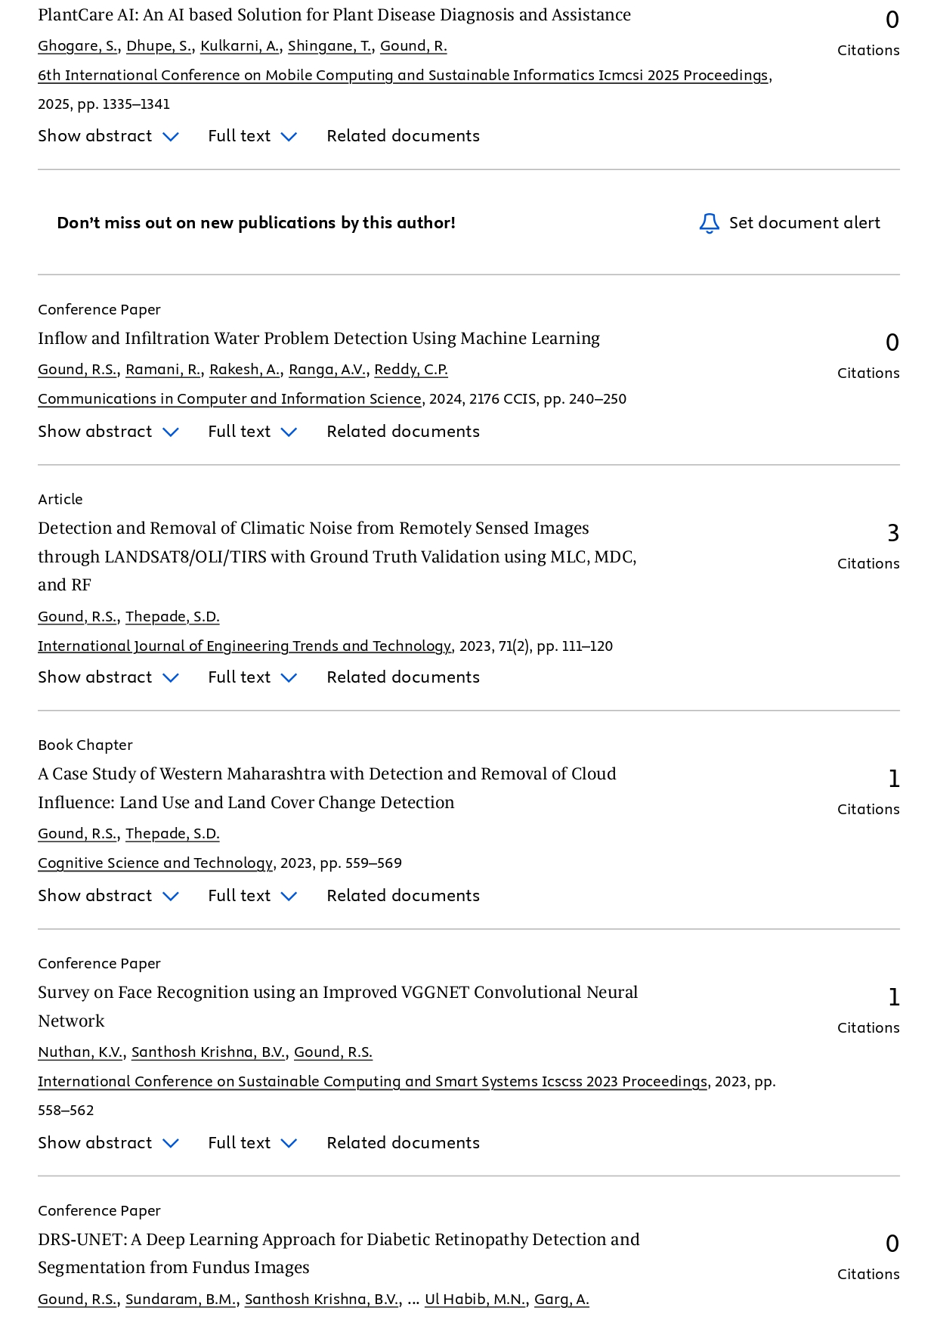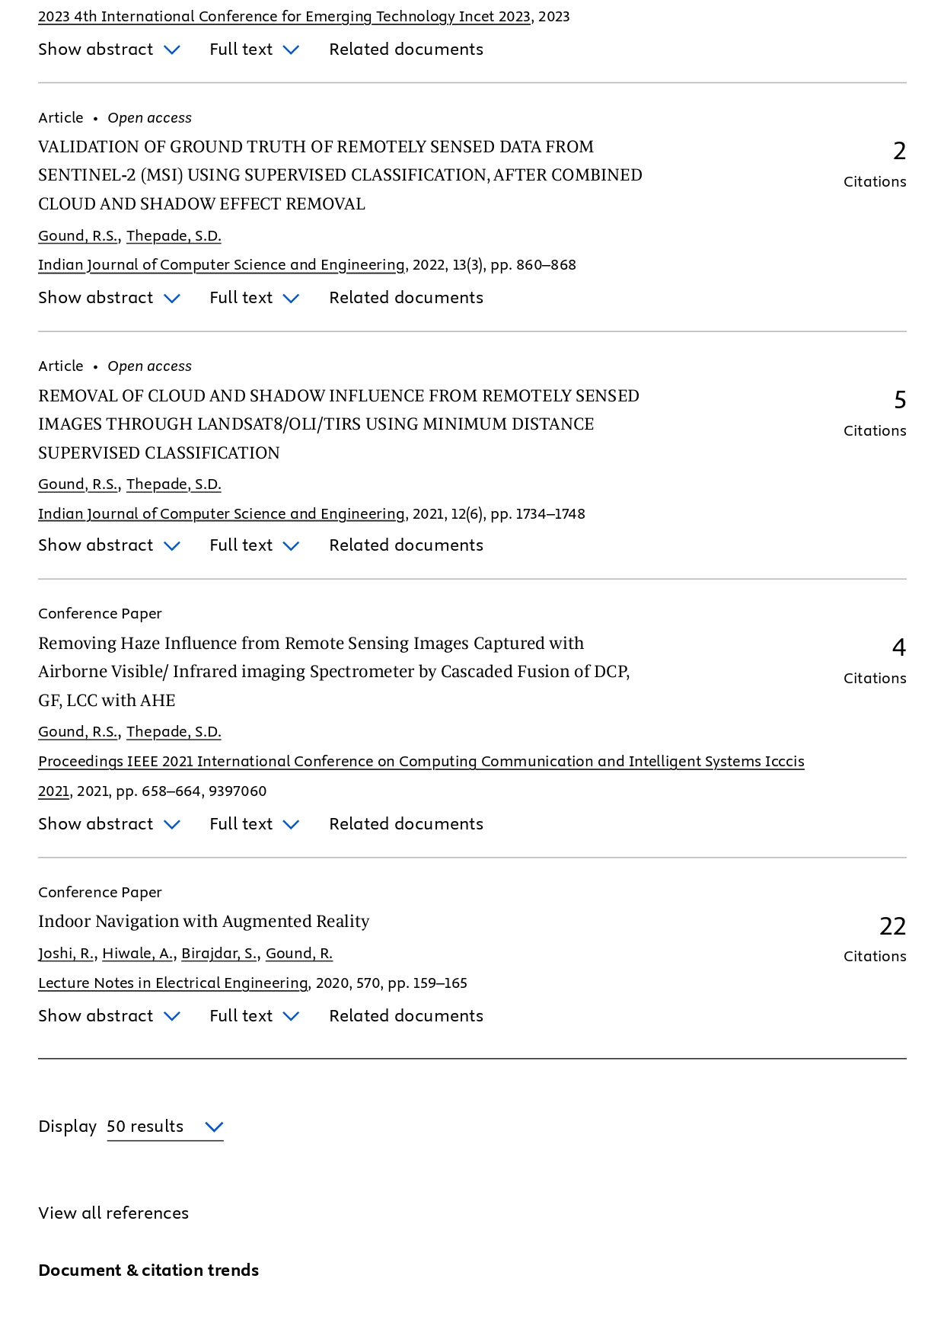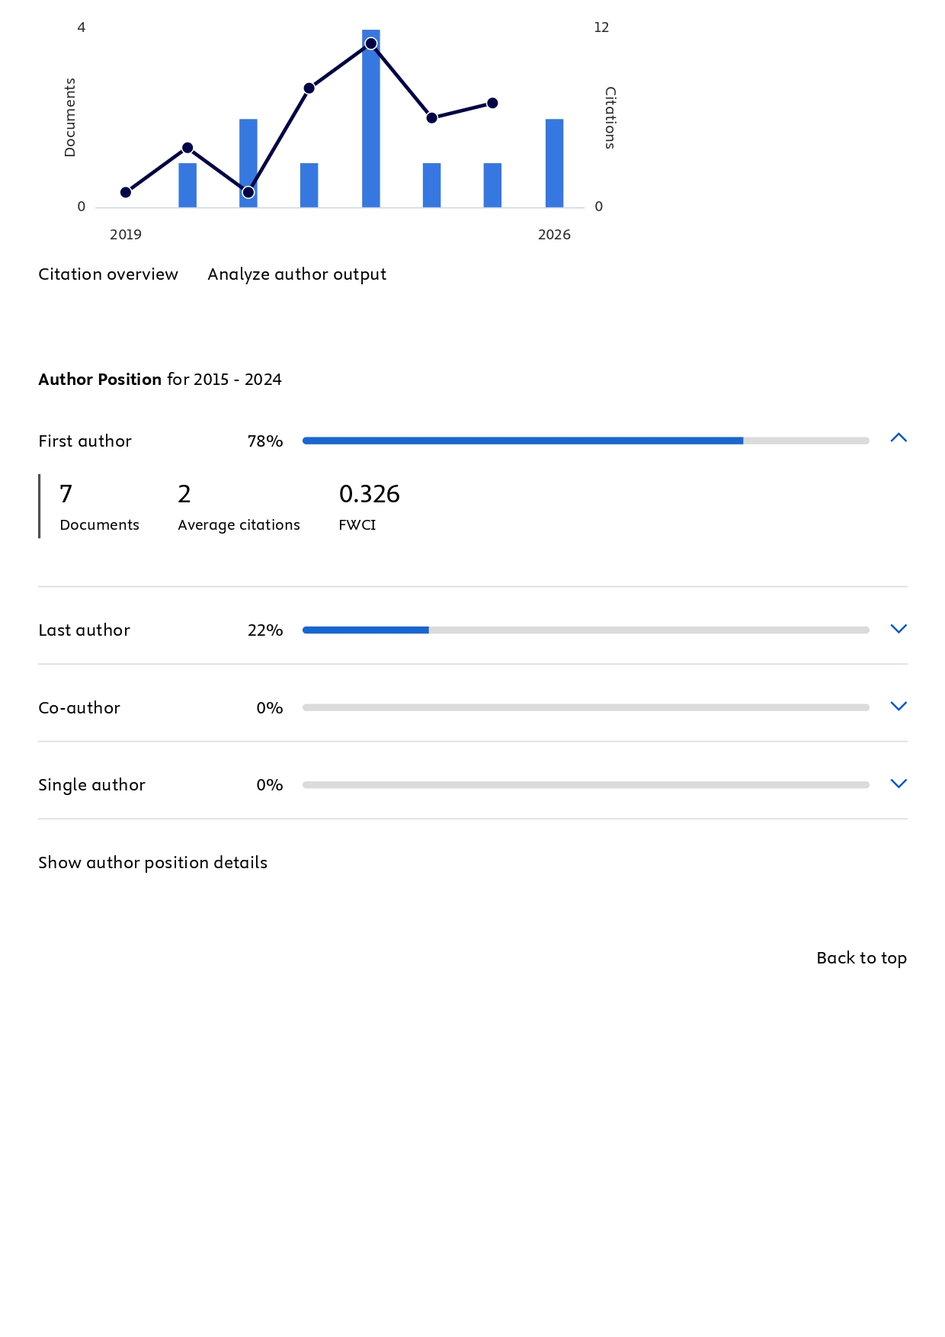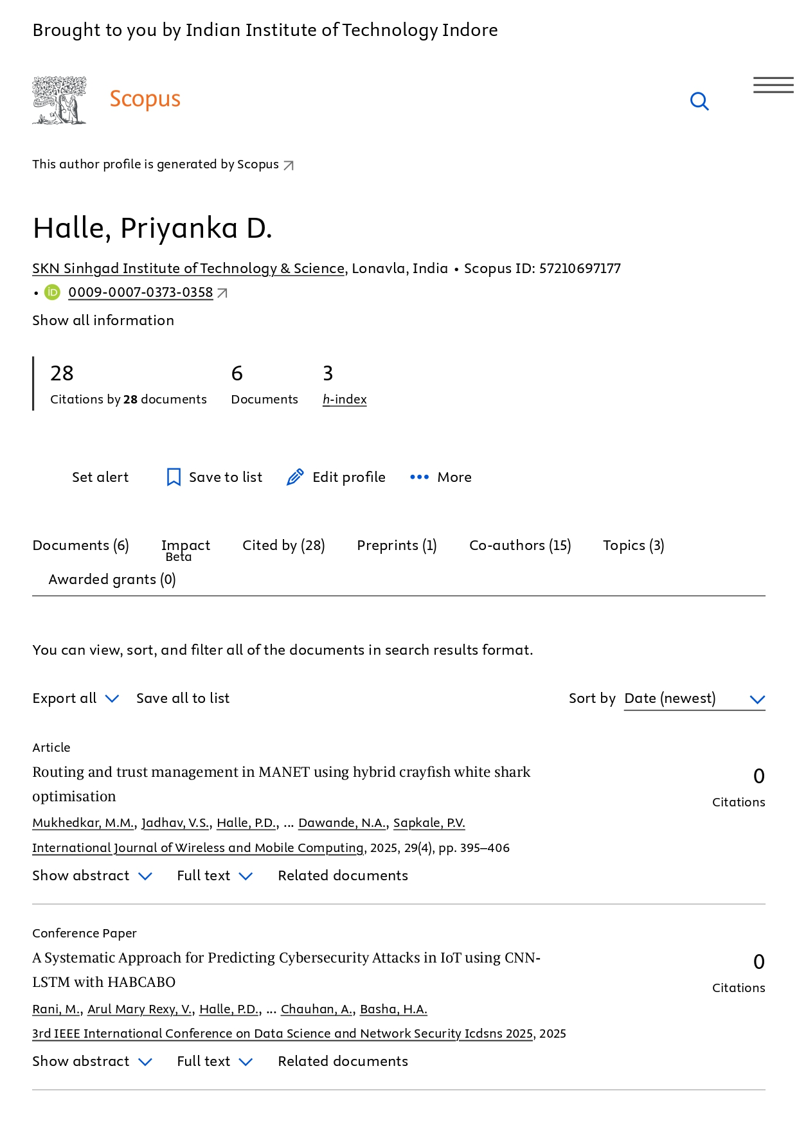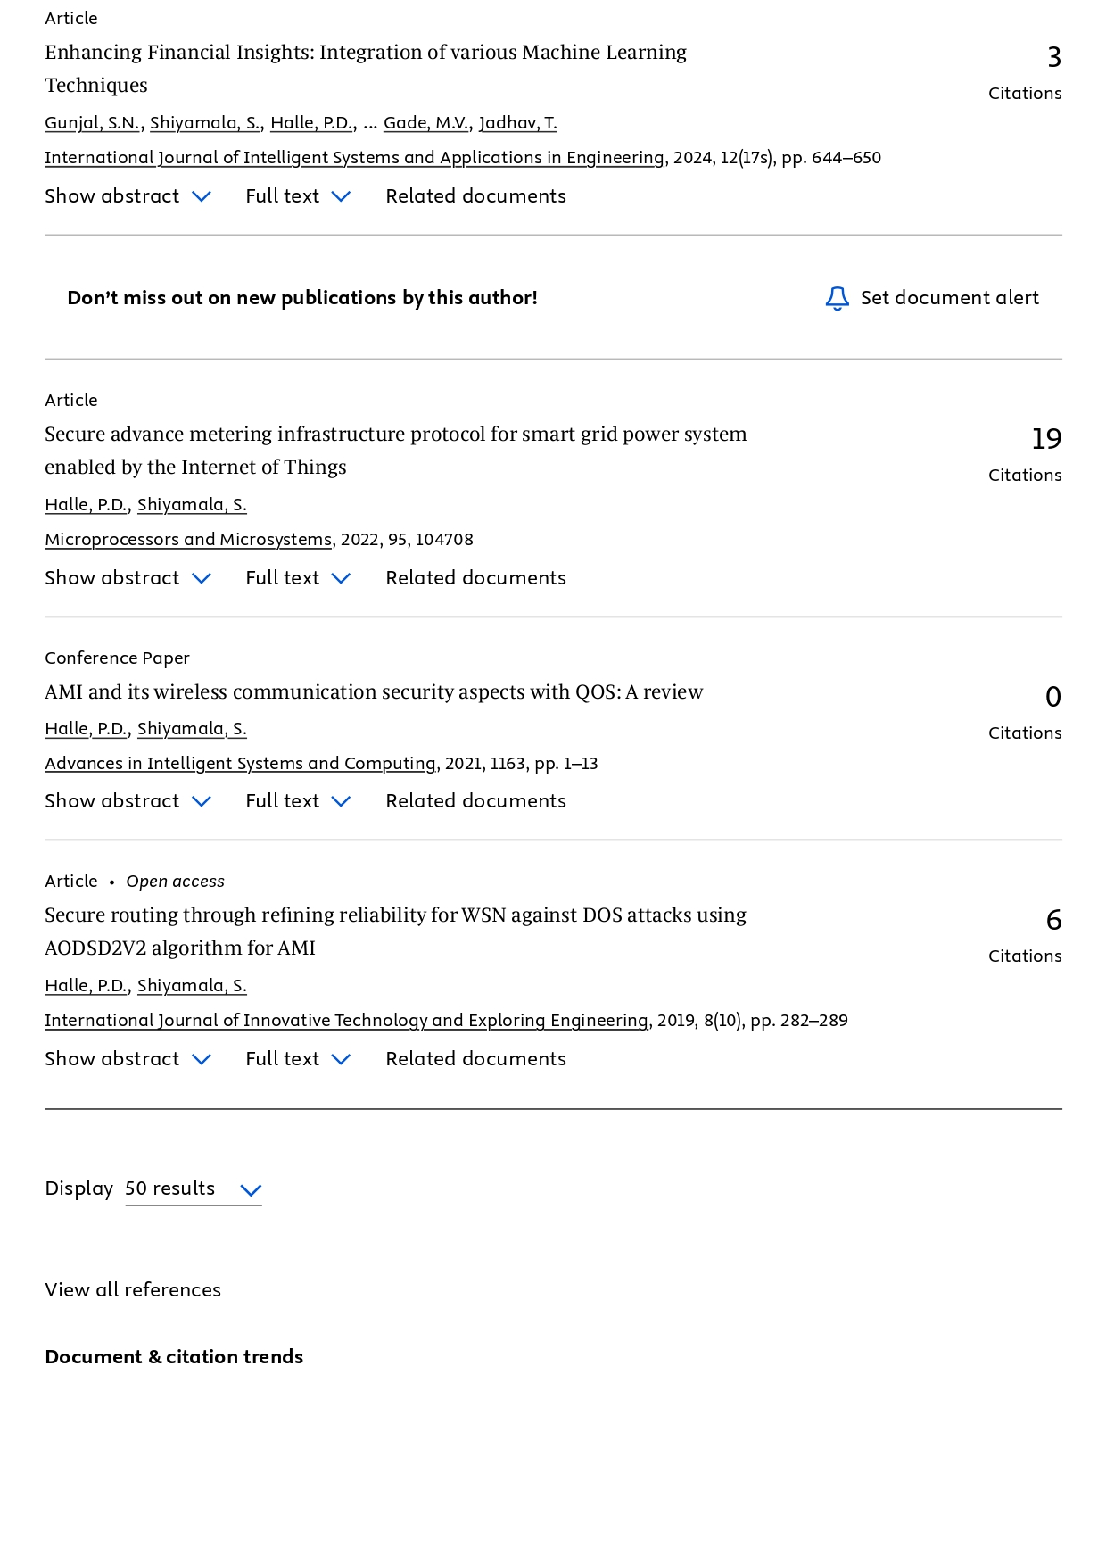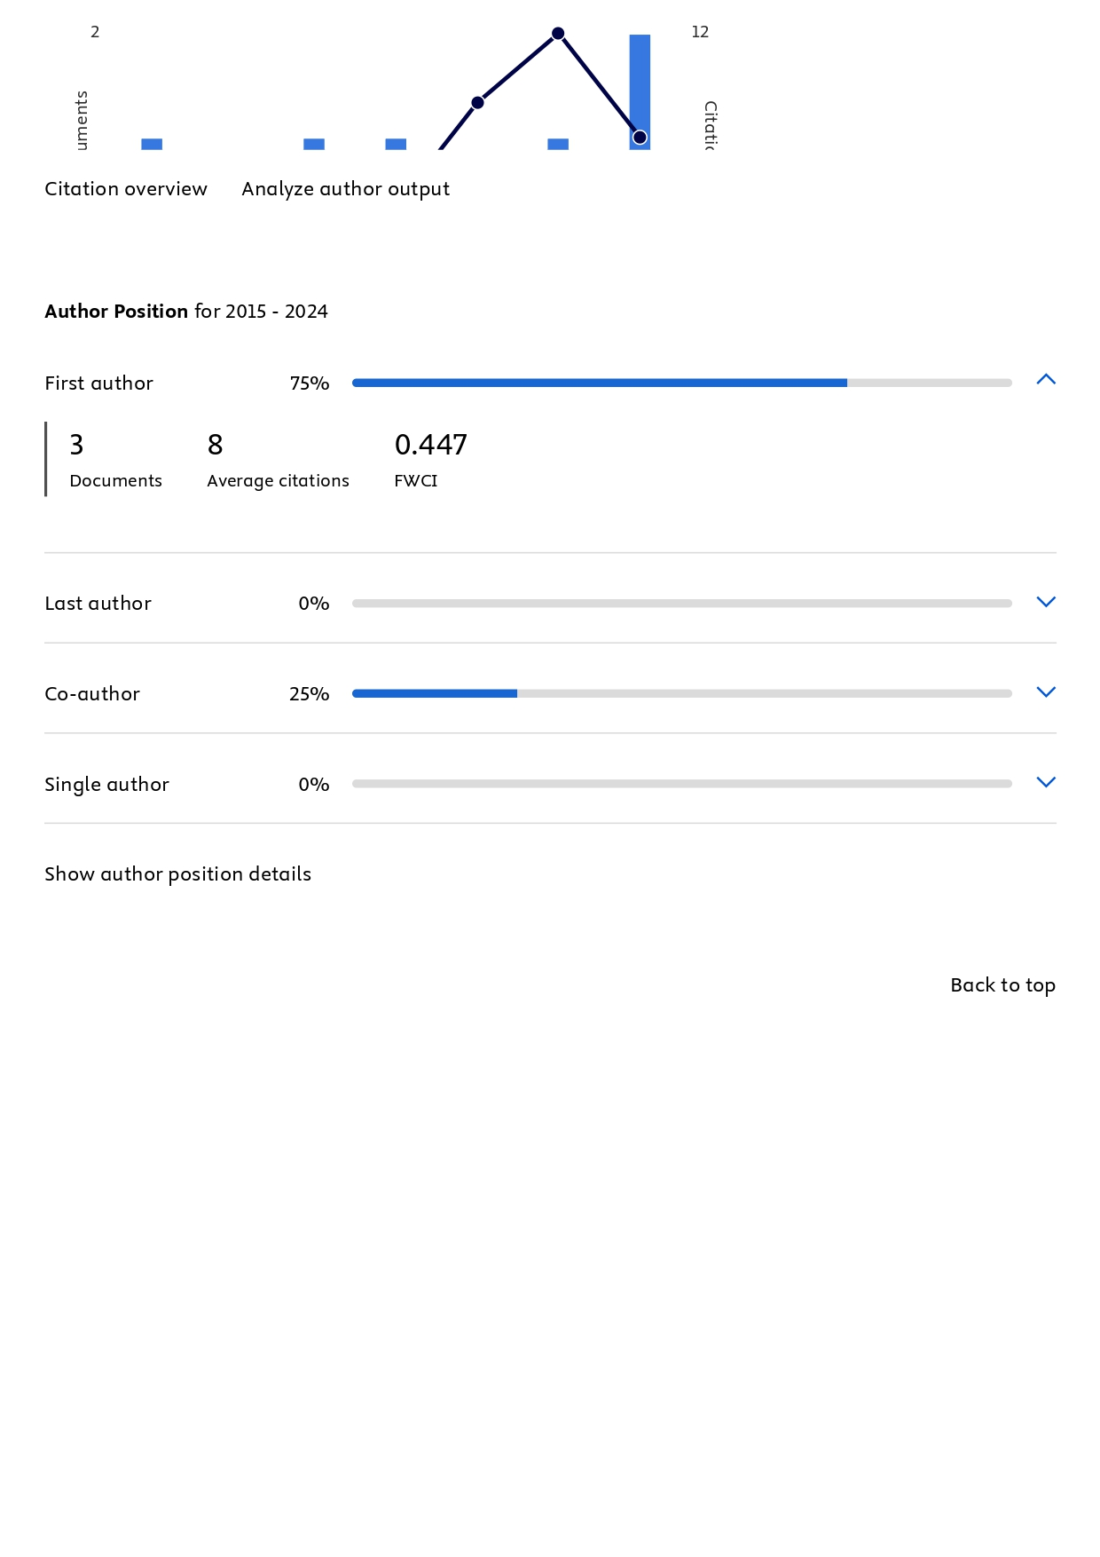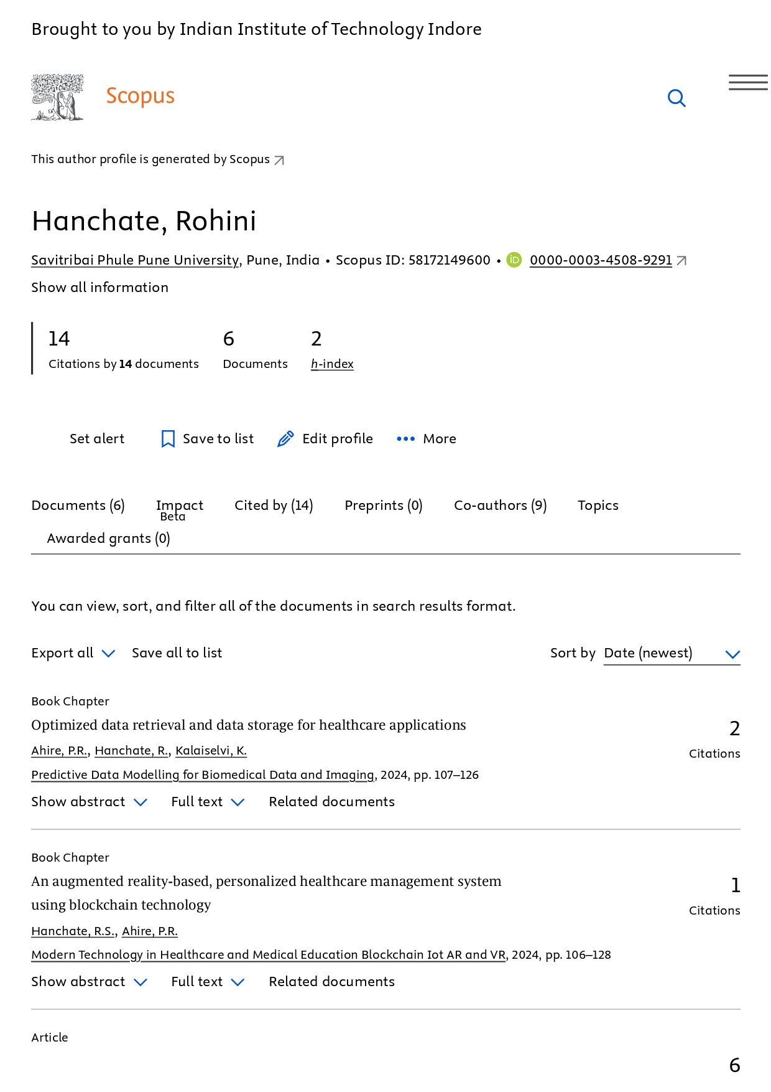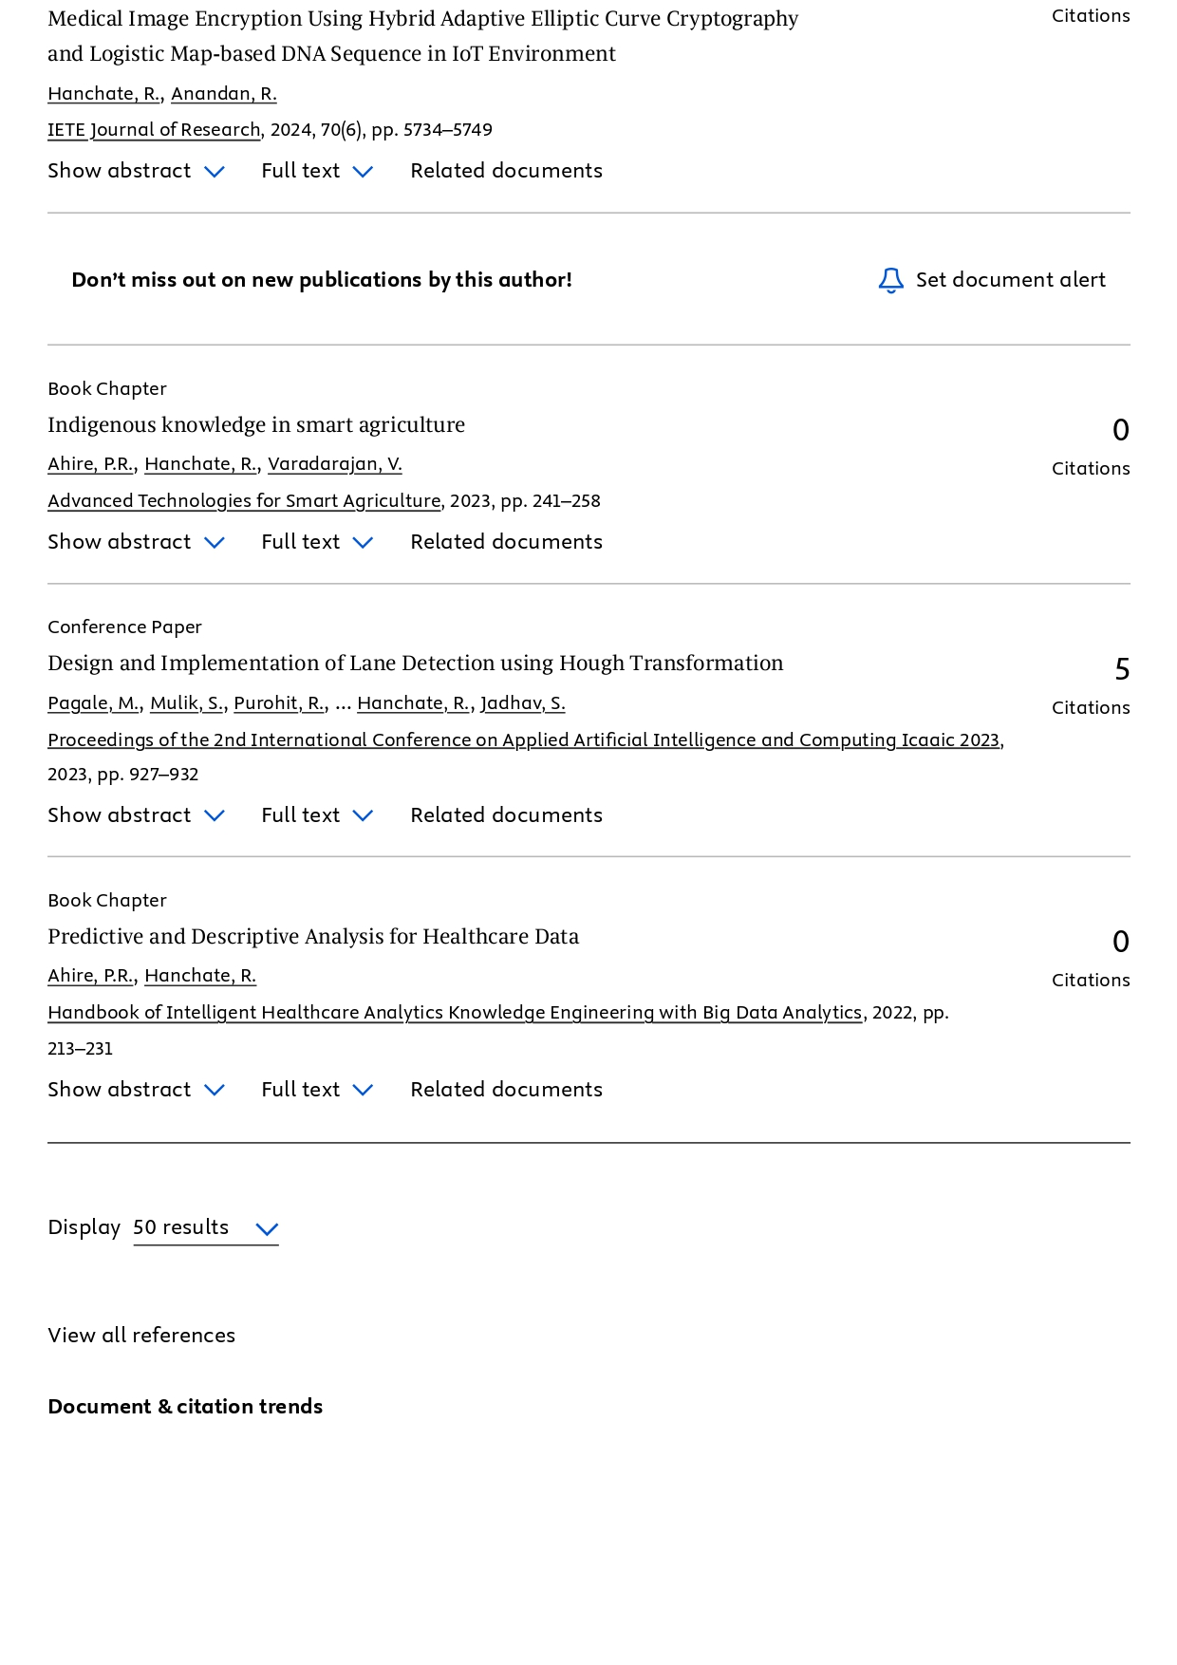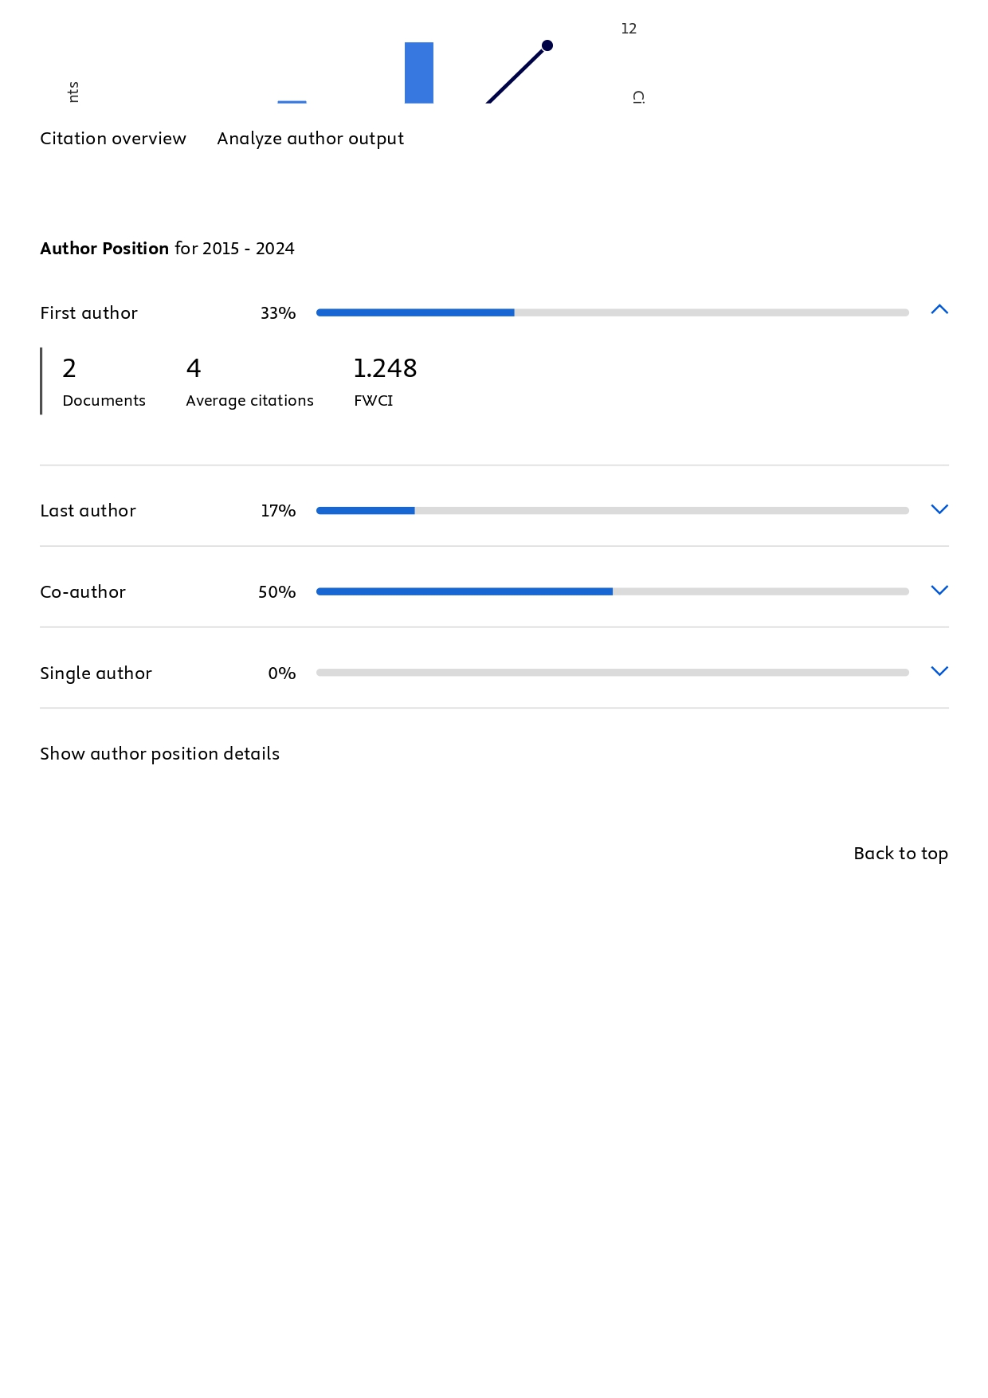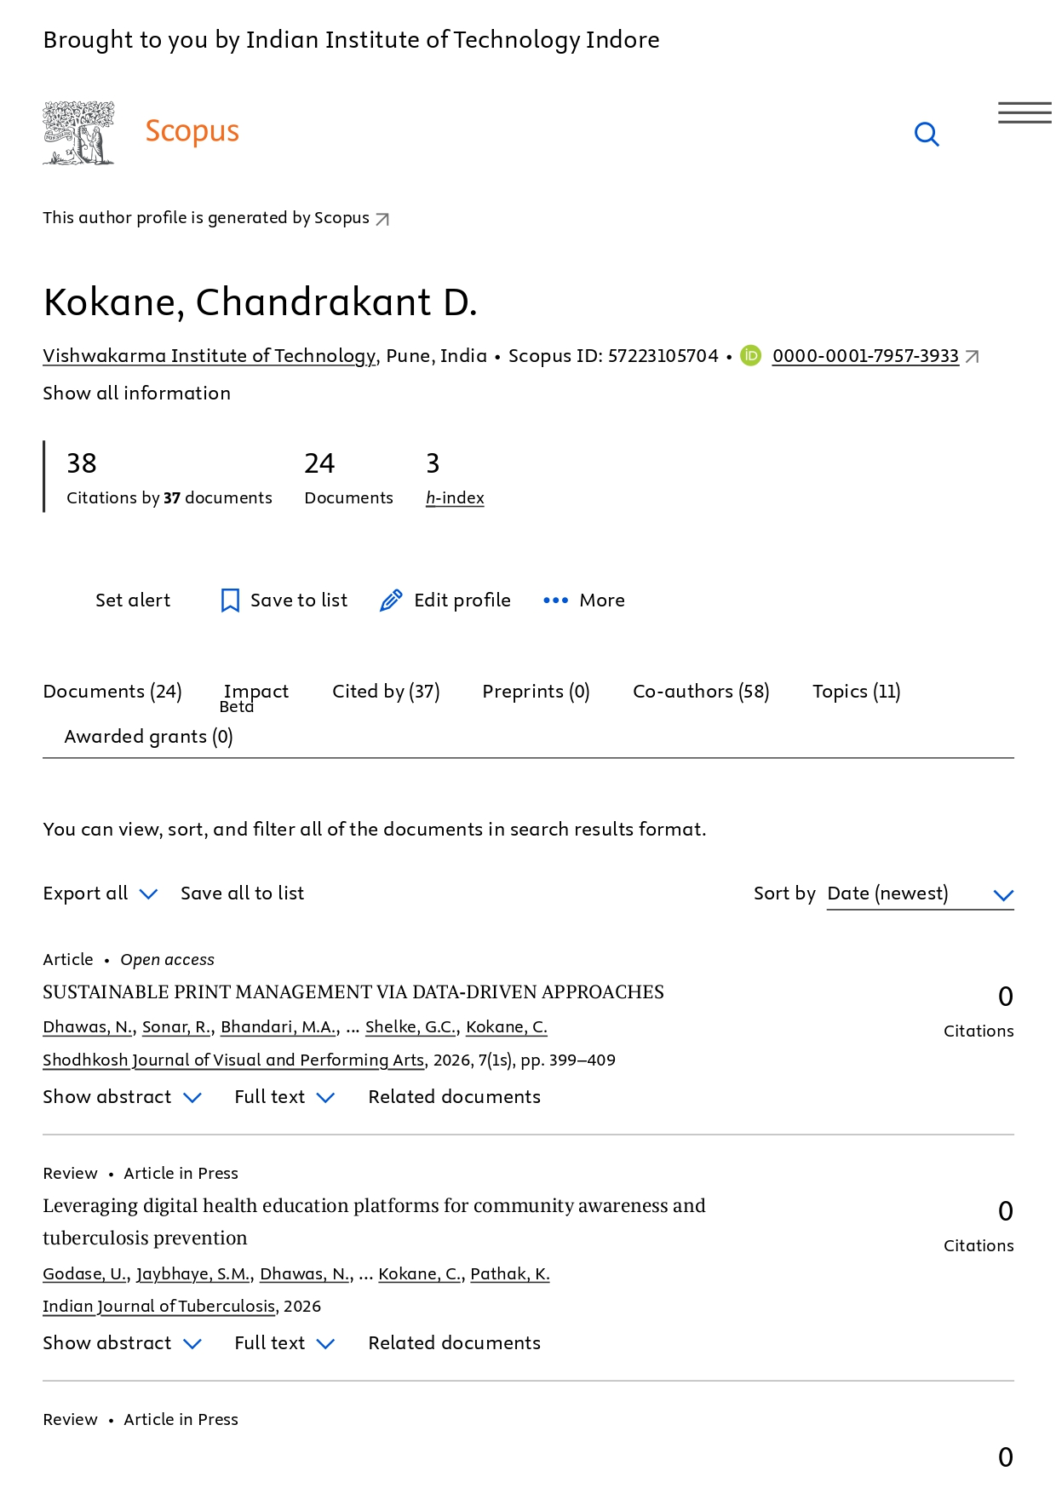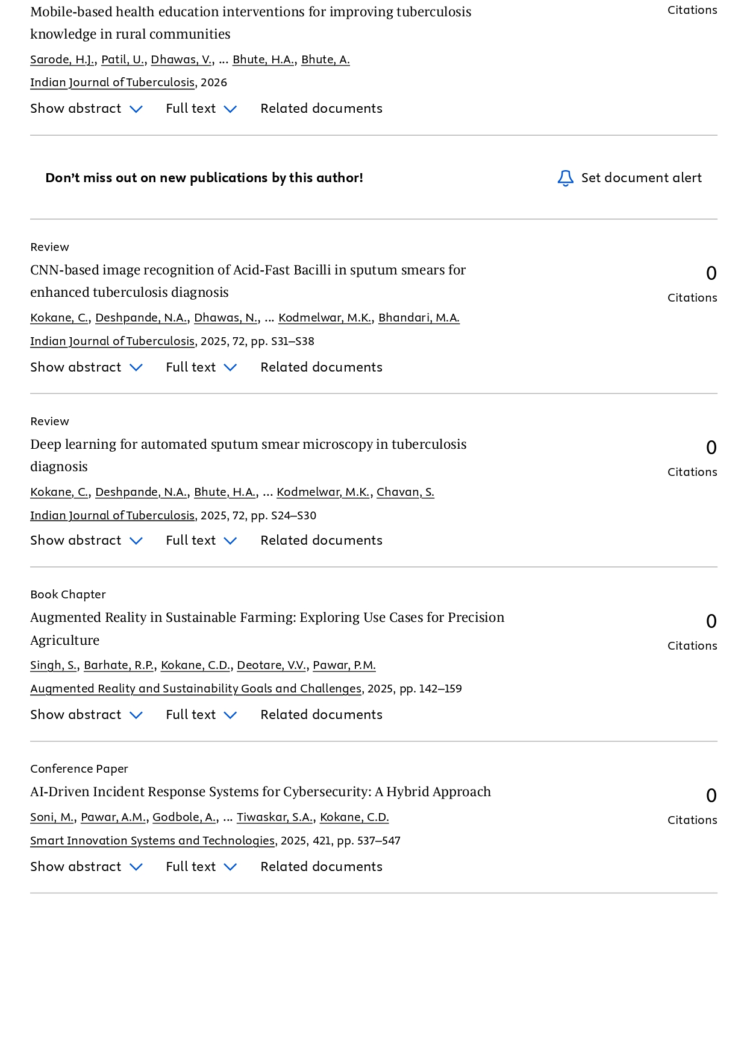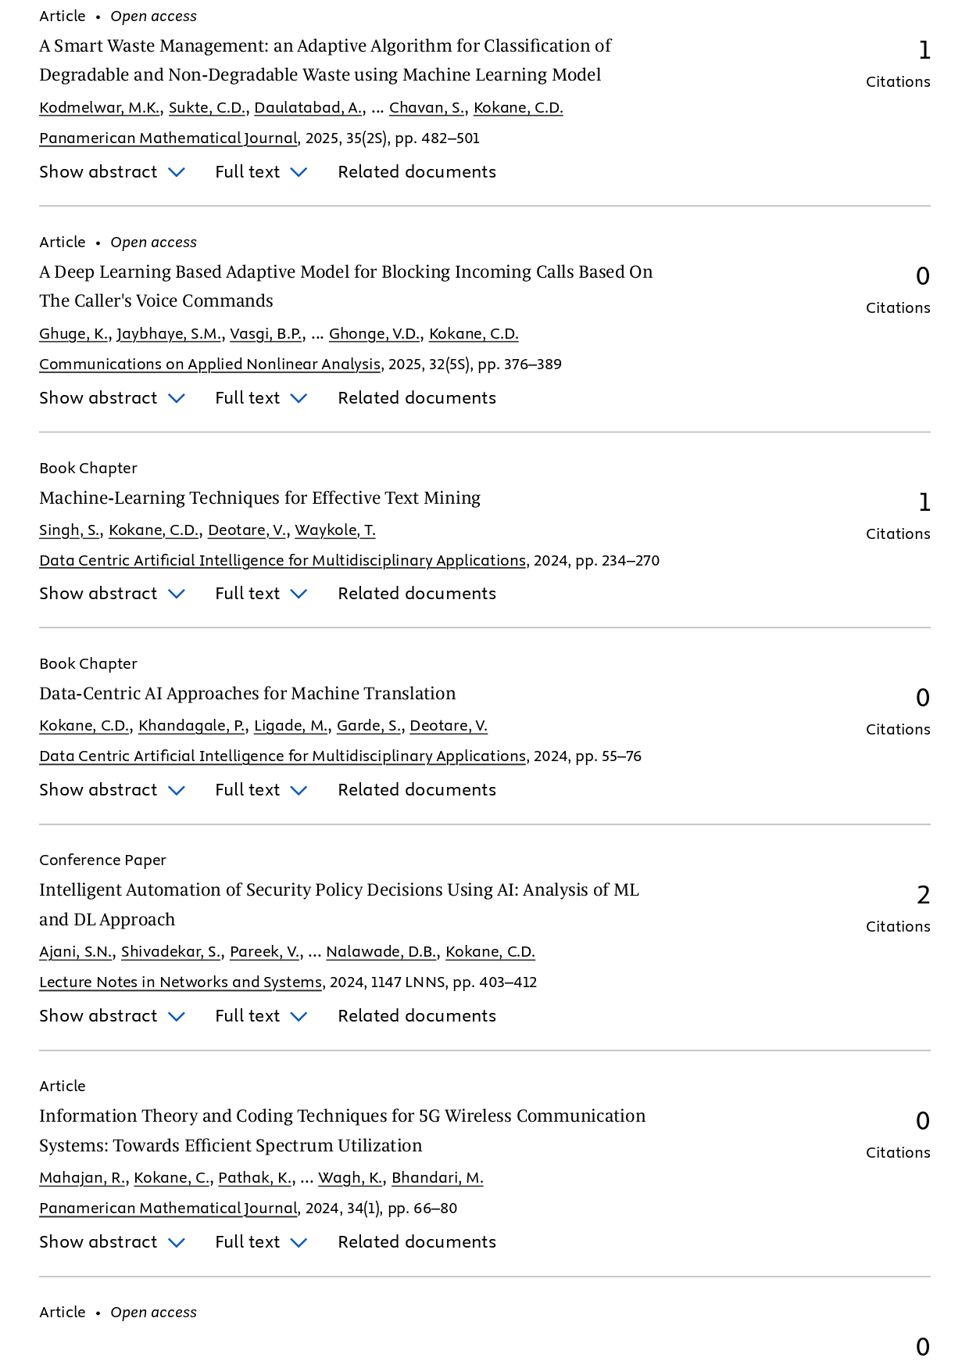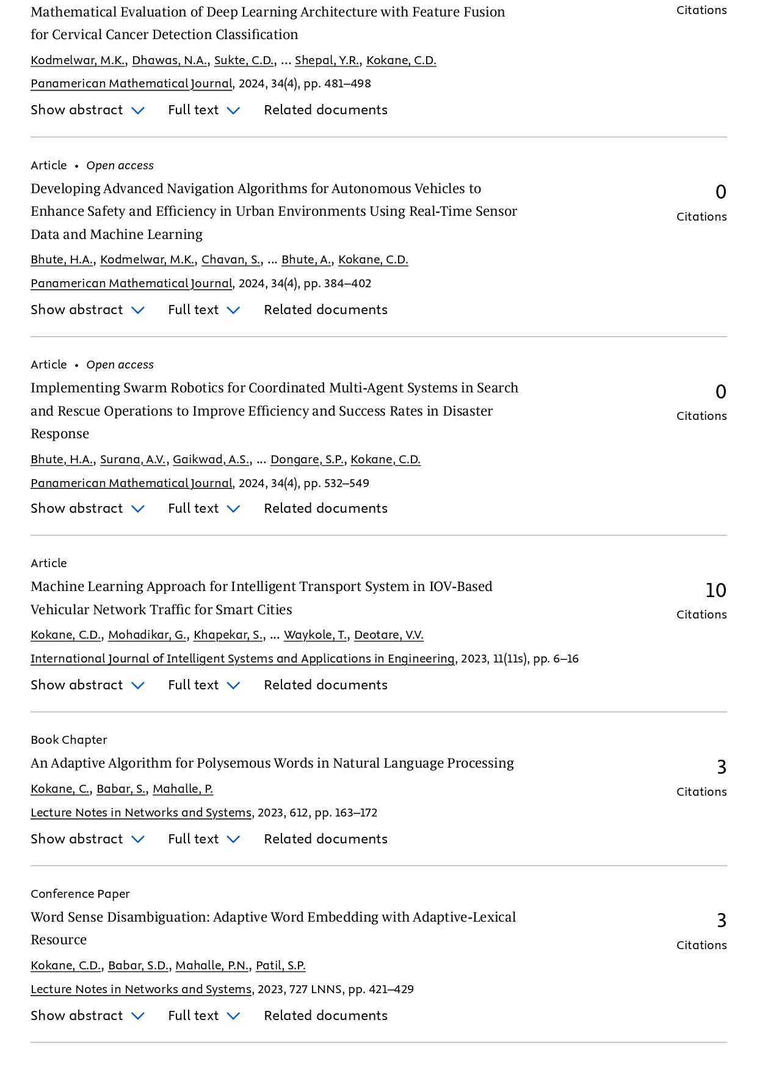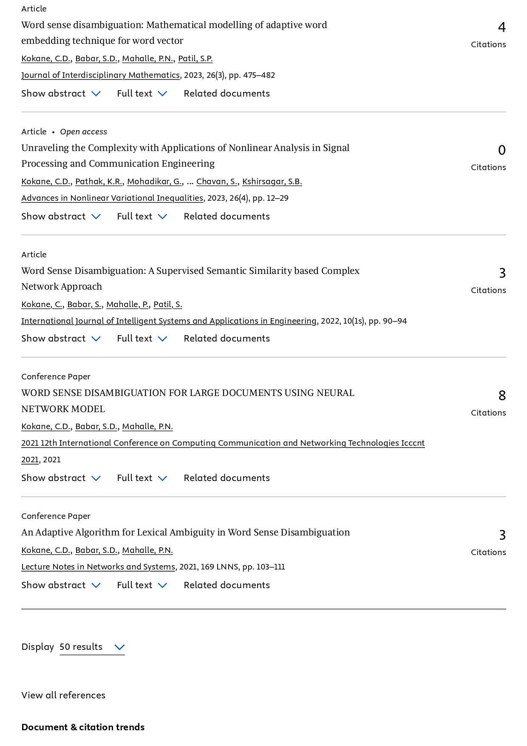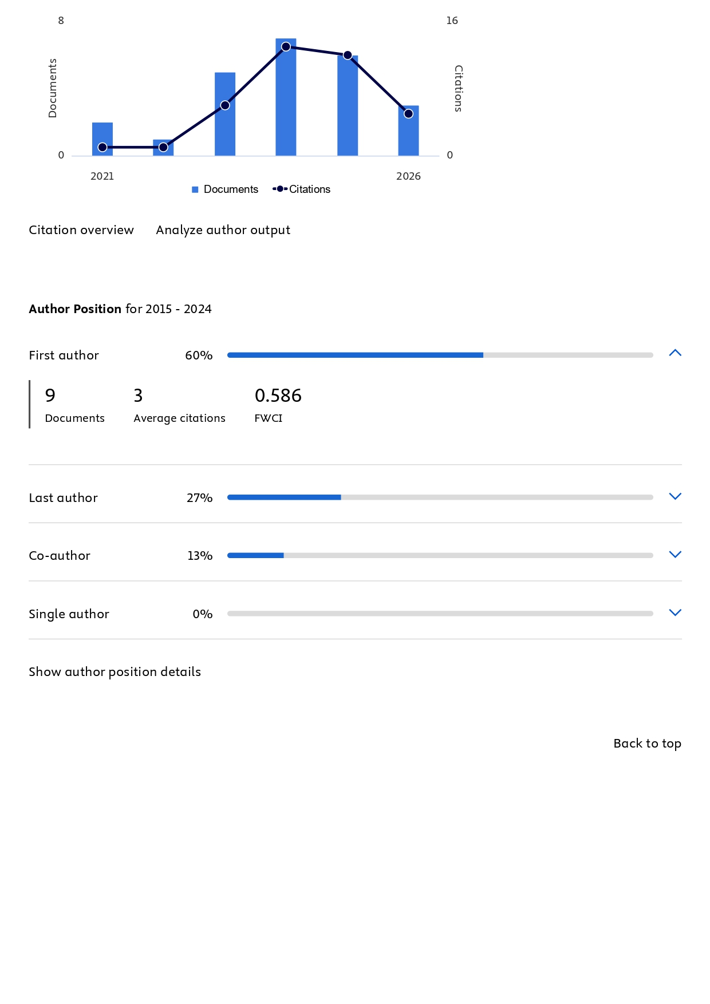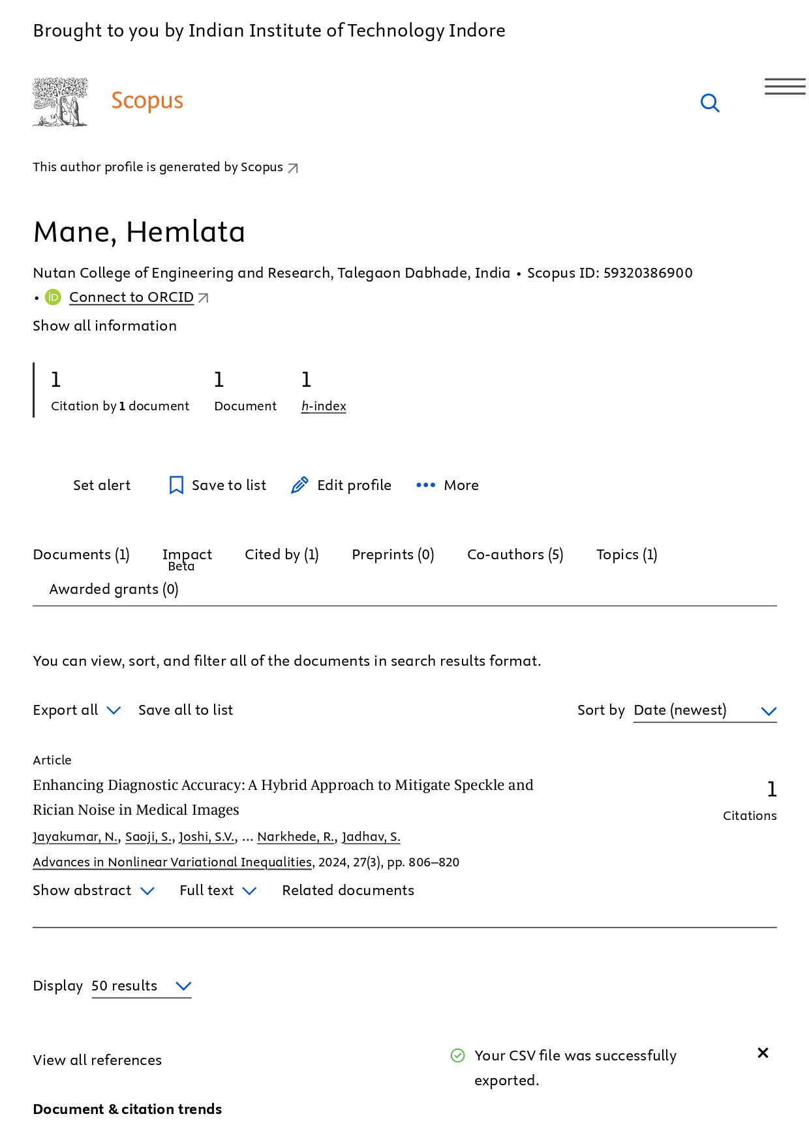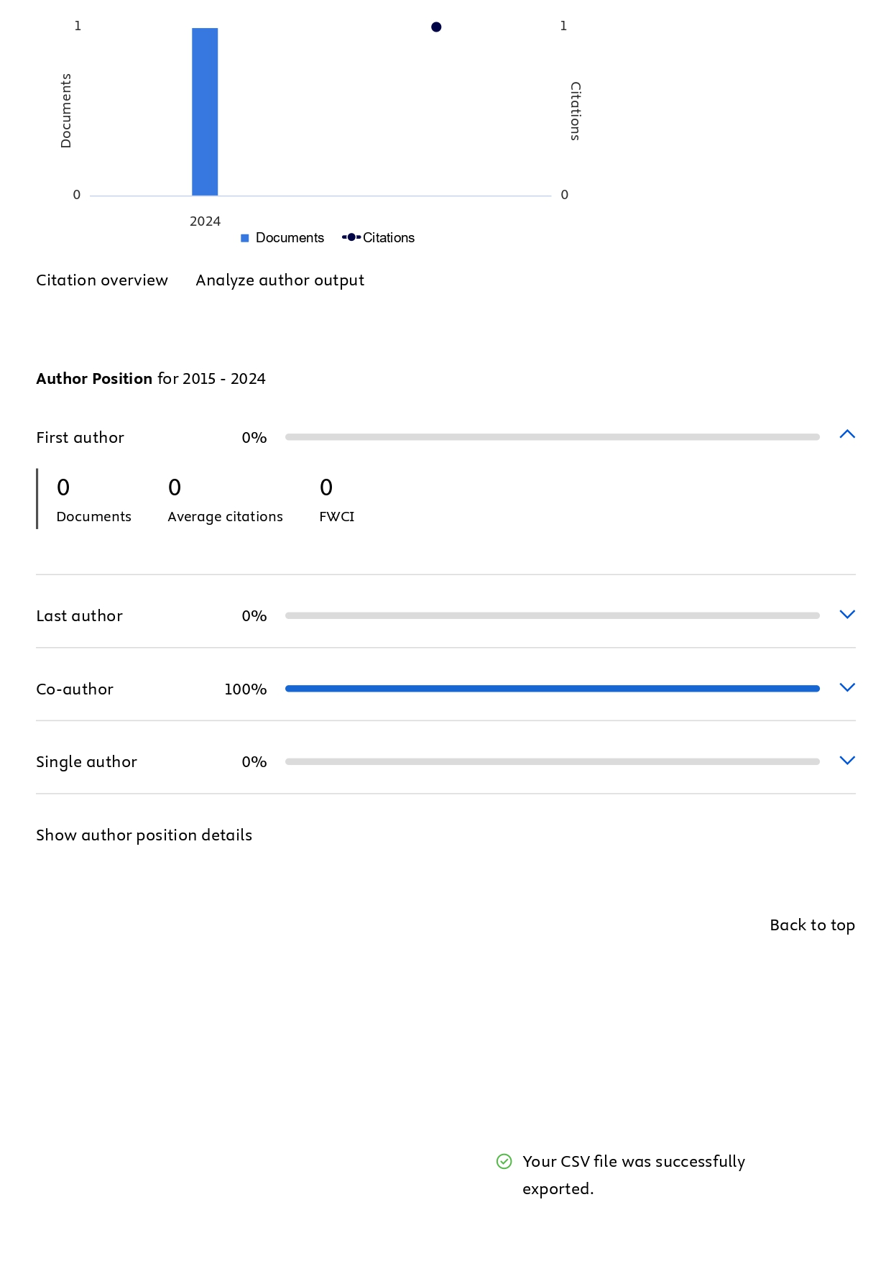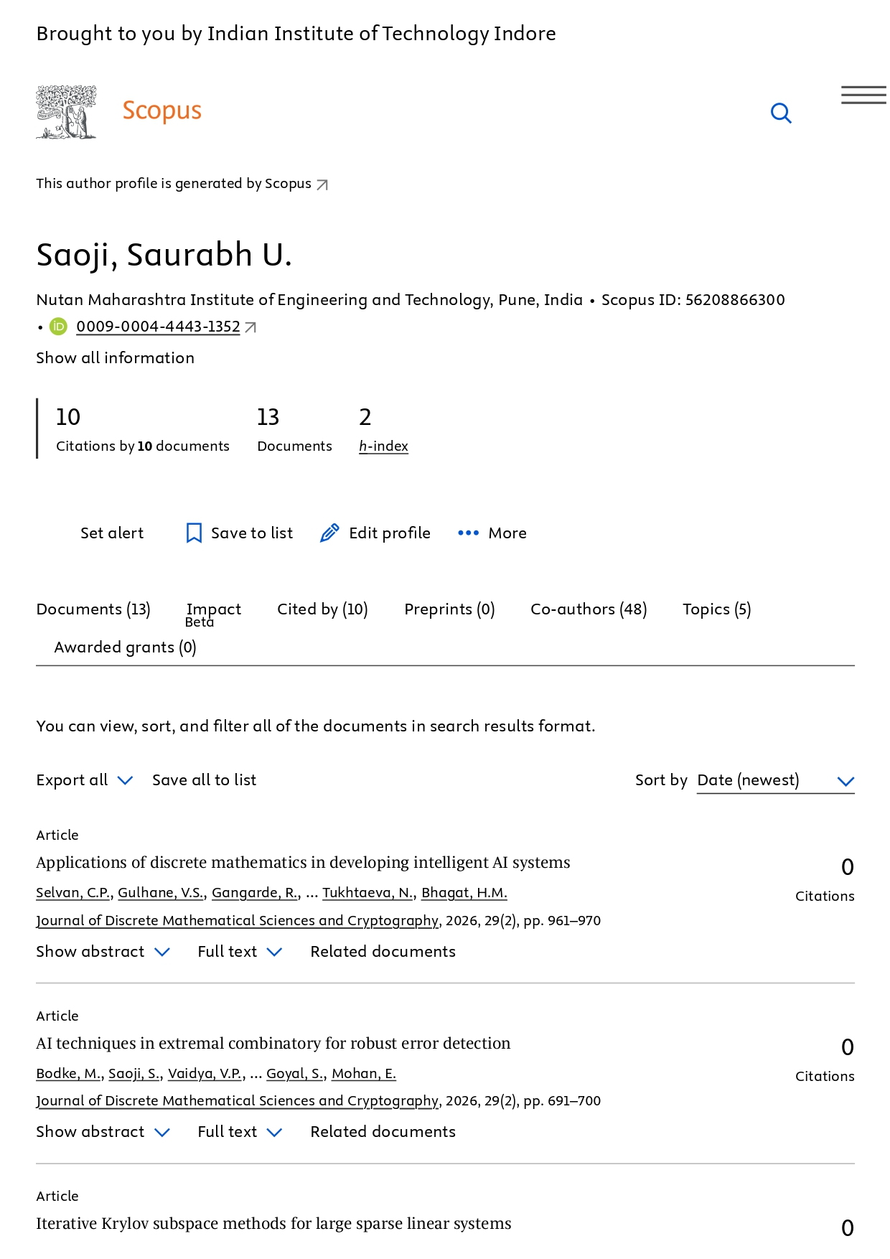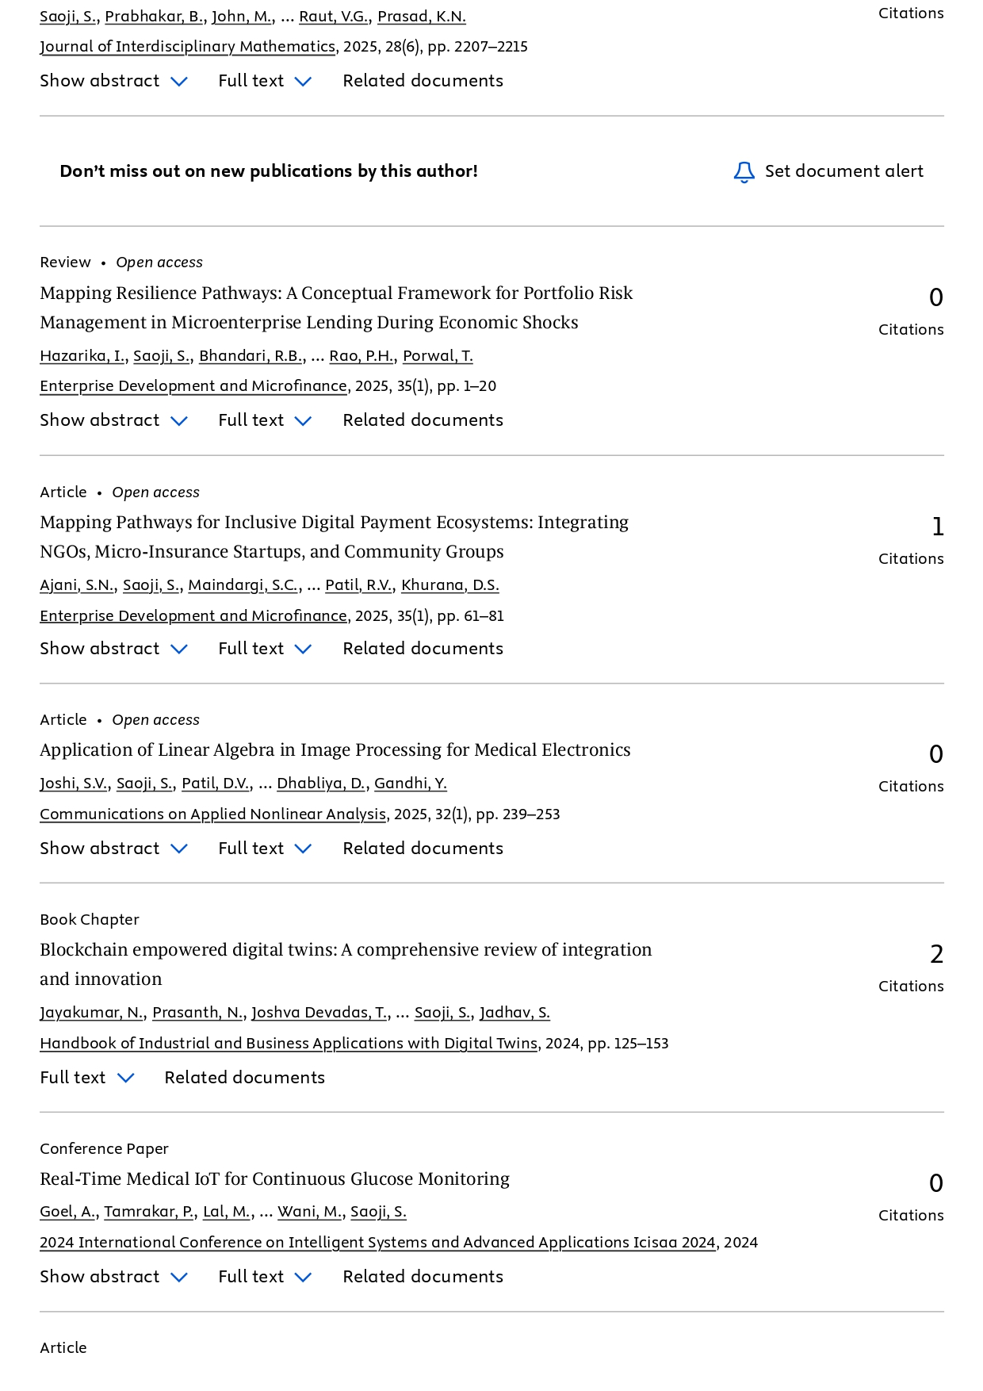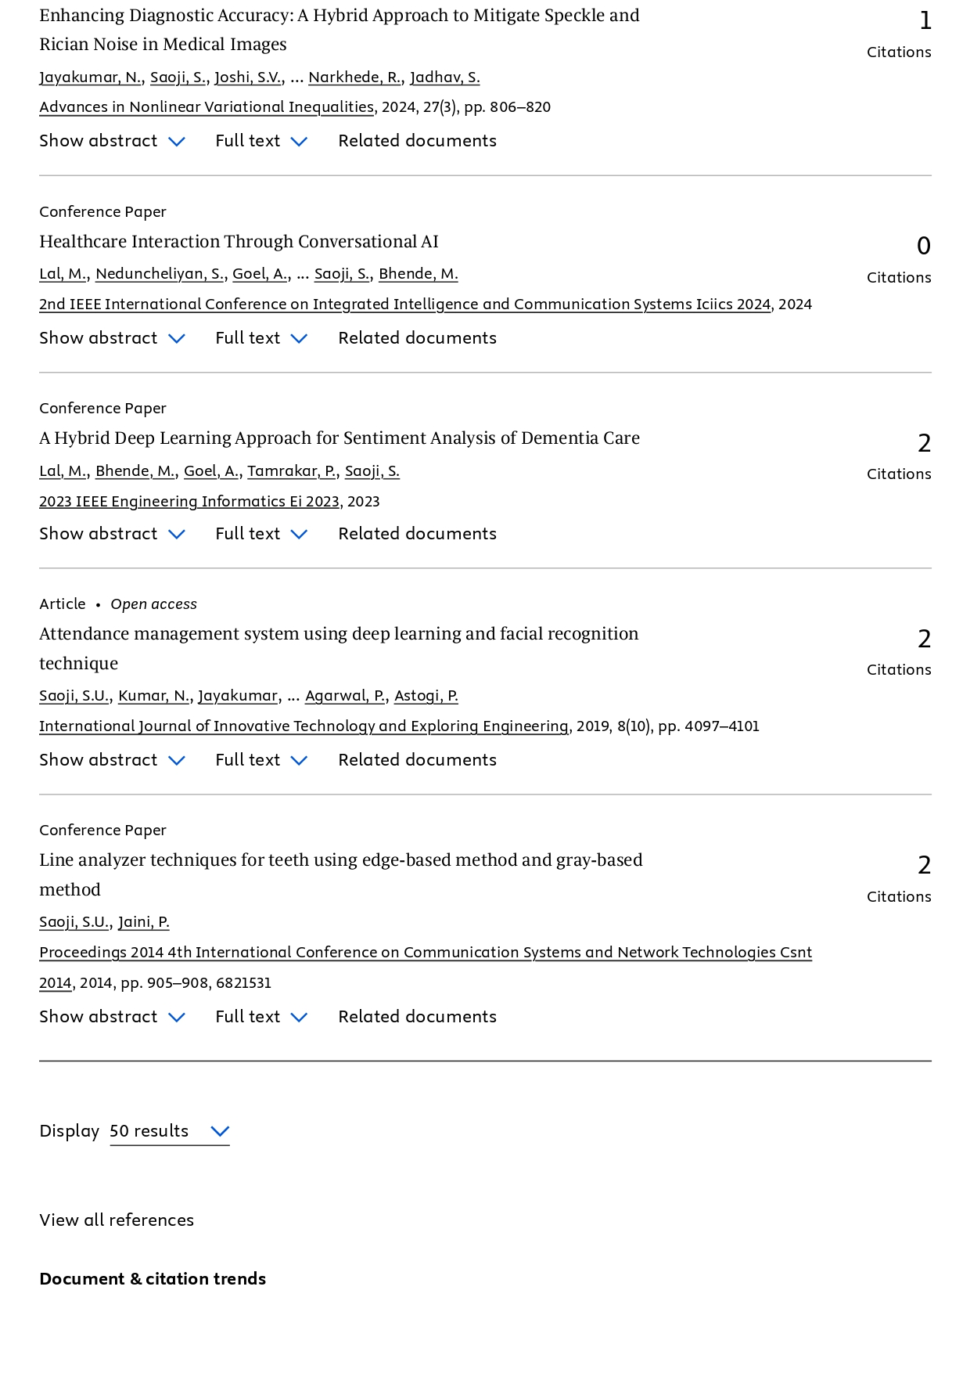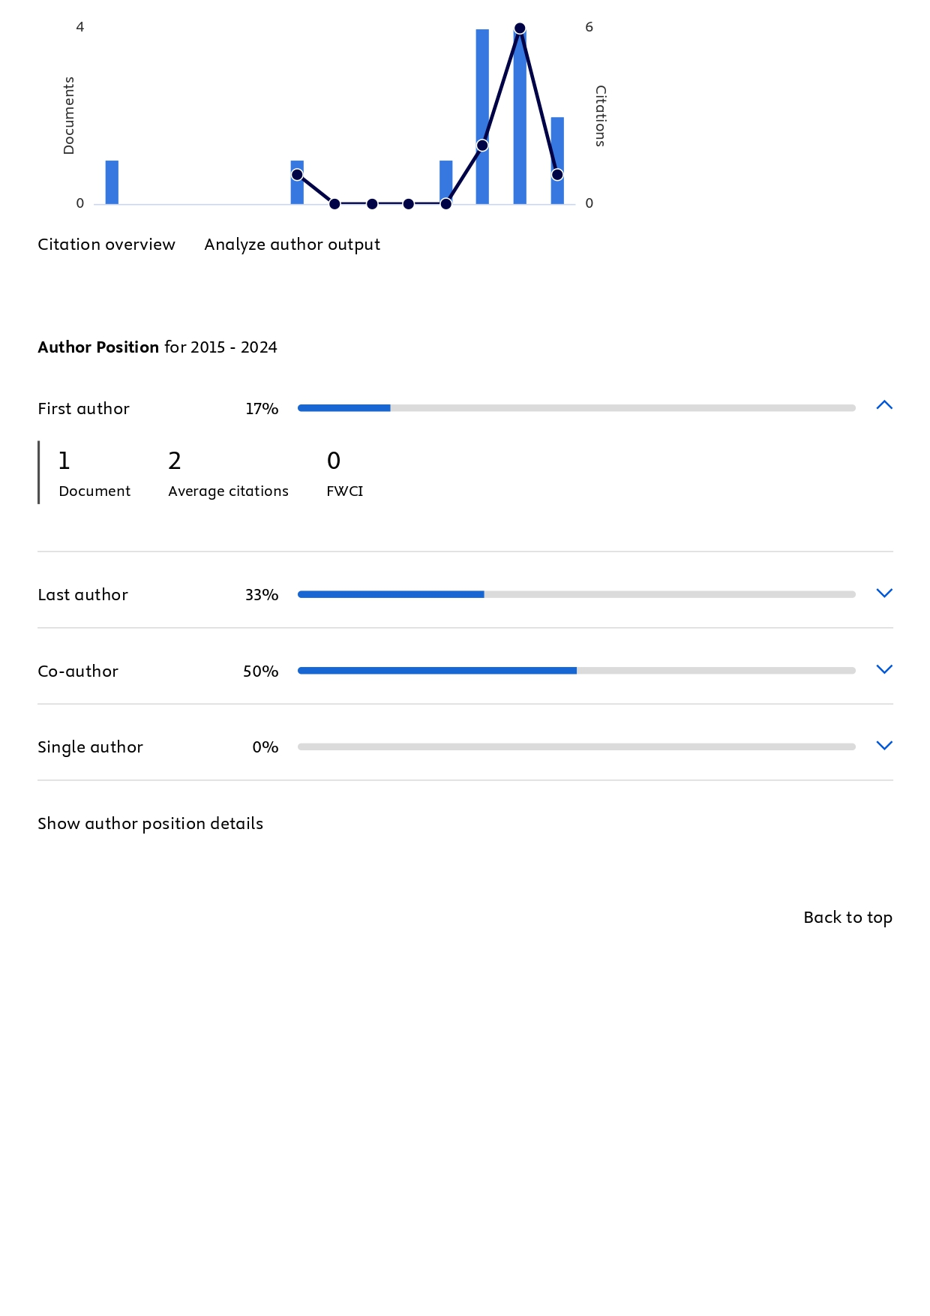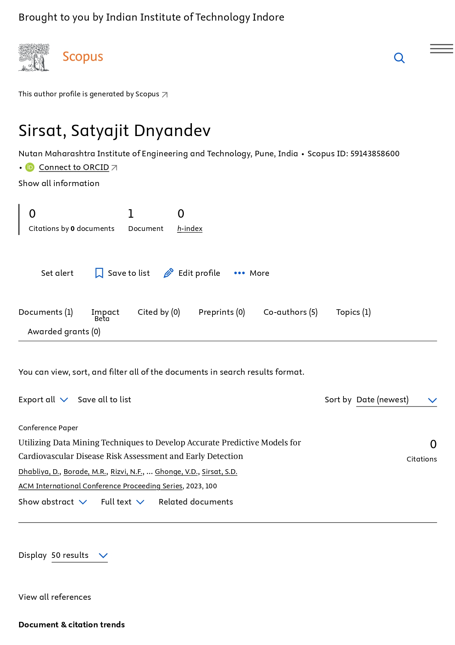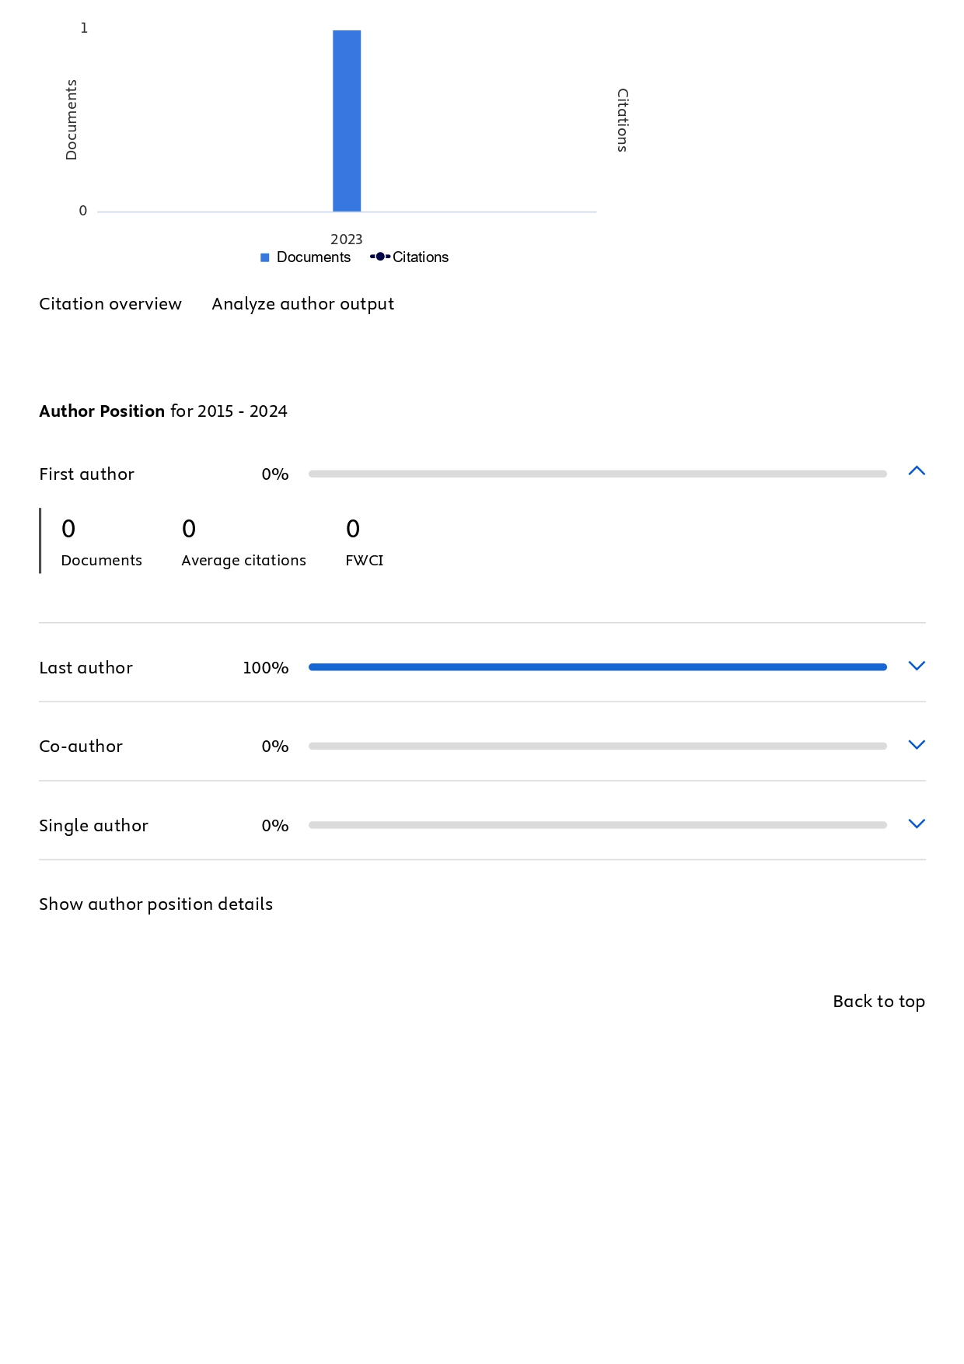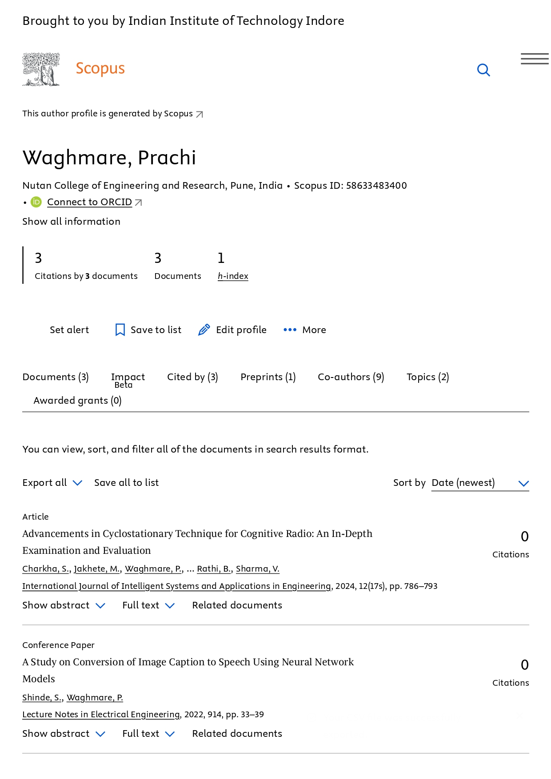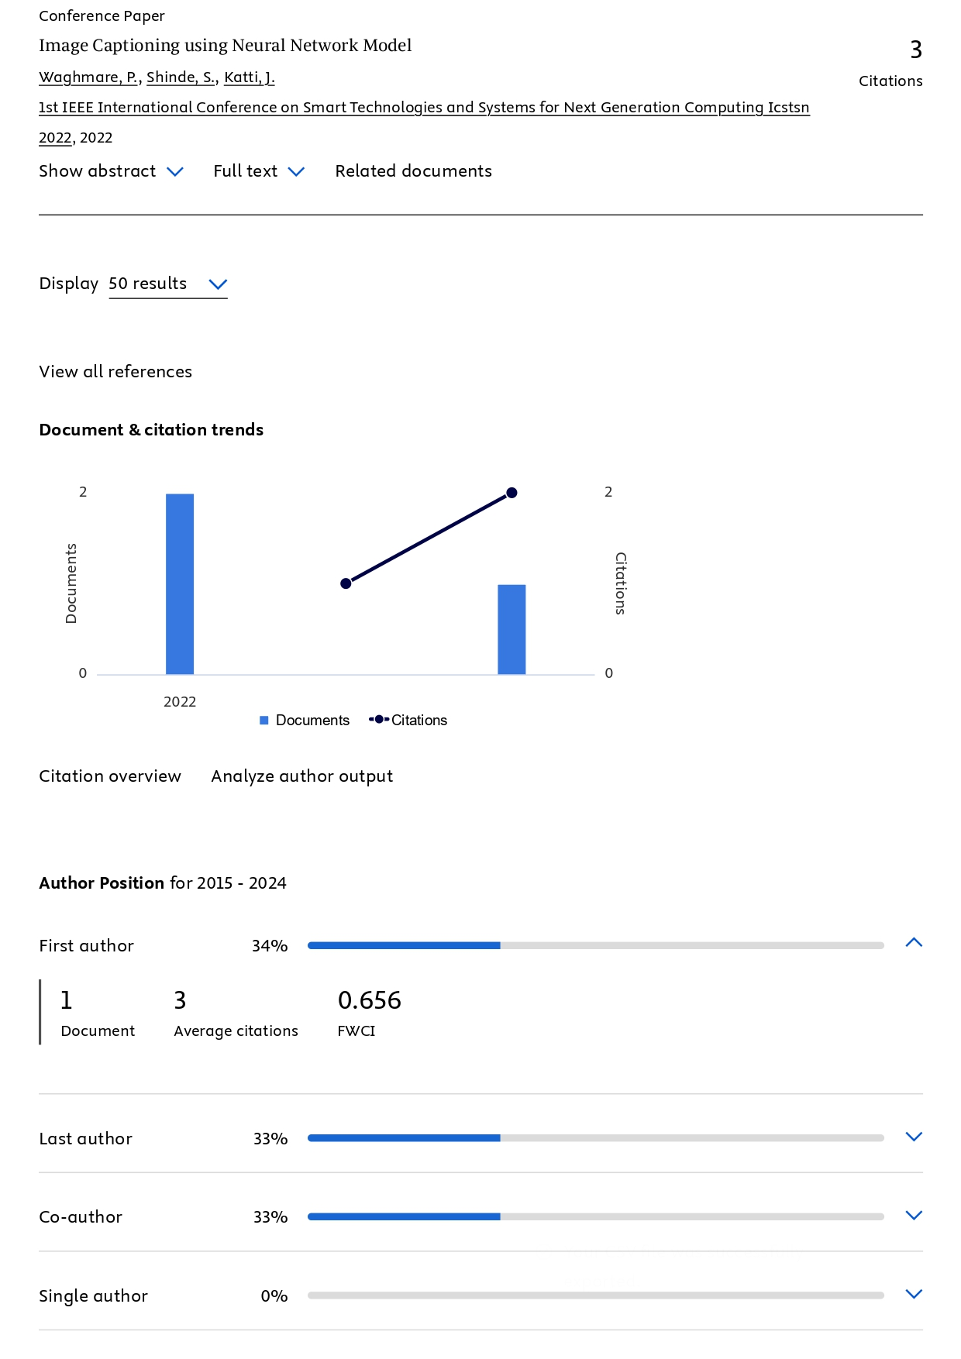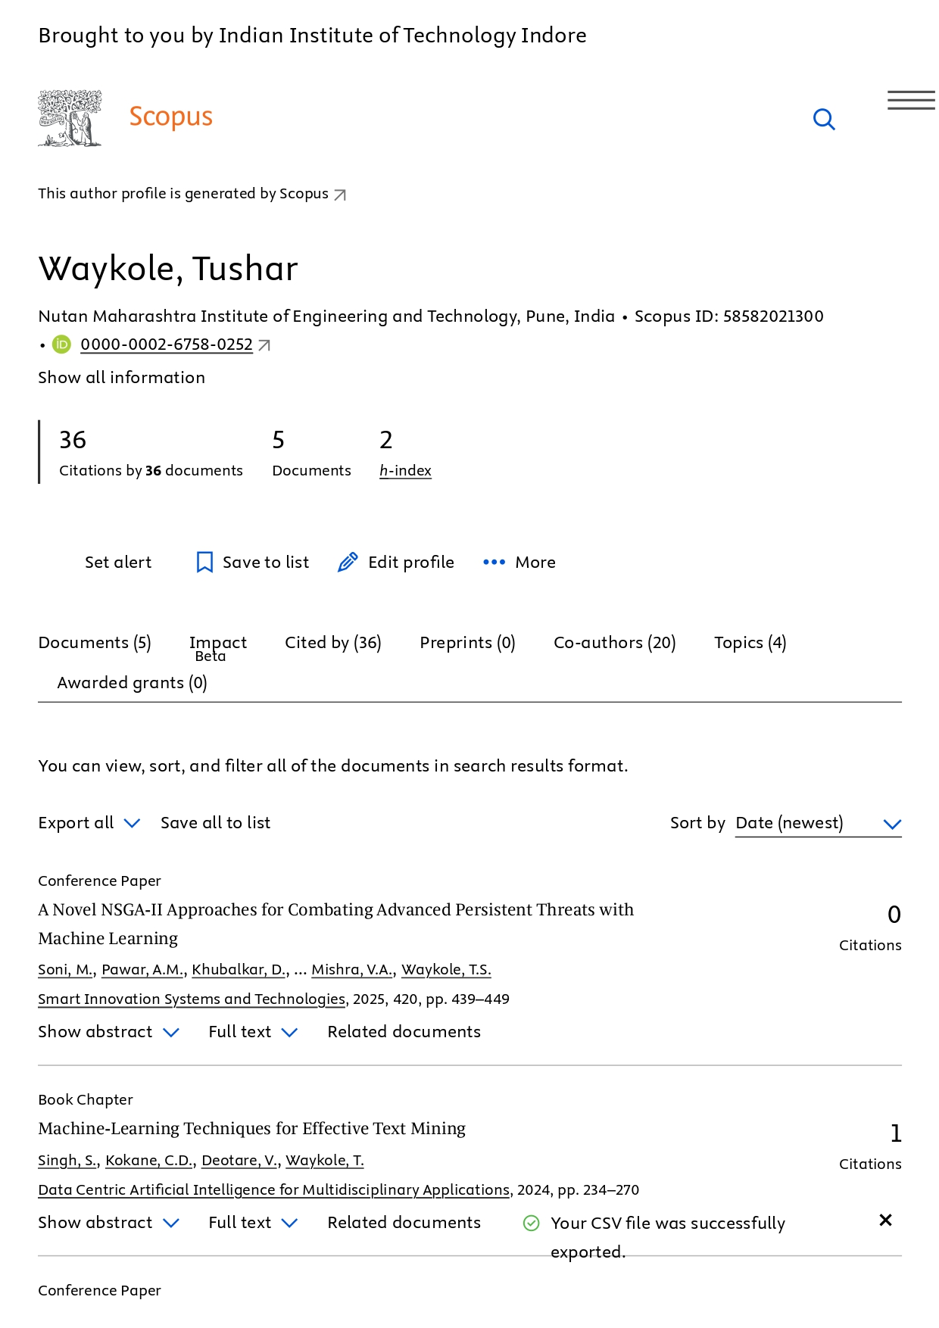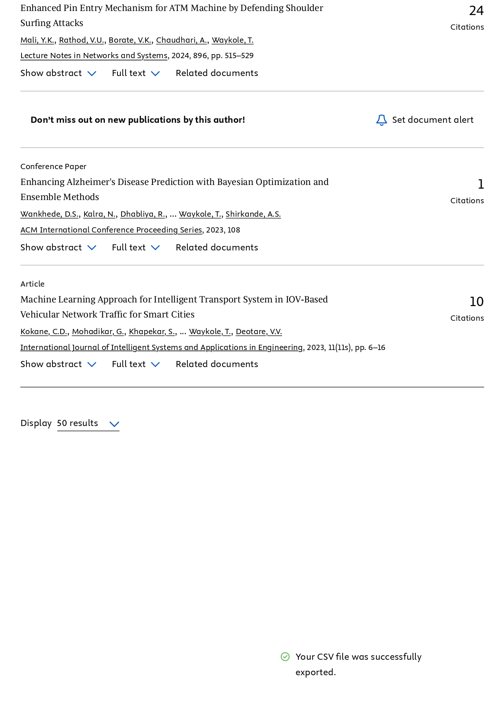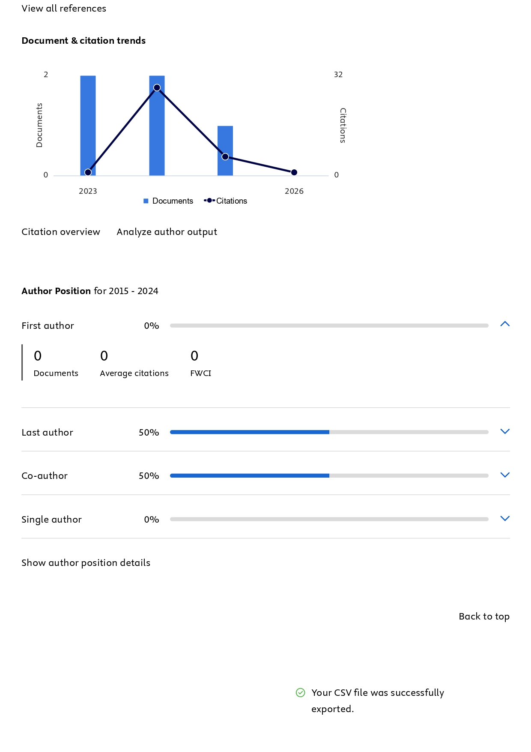

D_Staff Wise Google Scholar Profile

Sr. No. | Staff Name | Google Scholor Link | Citation
Sr. No. | Staff Name | Google Scholor Link | 2026 | 2025 | 2024 | 2023
1 | Dr. Pramod Patil | Https://Scholar.Google.Com/Citations?Hl=En&User=Y-Uthvgaaaaj | 27 | 175 | 116 | 95
2 | Dr.Rahul Patil | Https://Scholar.Google.Com/Citations?Hl=En&User=Ygmxa8yaaaaj | 14 | 94 | 42 | 29
3 | Dr.Prasad Dhore | Https://Scholar.Google.Com/Citations?Hl=En&User=Speuc-Kaaaaj | 2 | 11 | 20 | 21
4 | Dr. Rohini S. Hanchate | Https://Scholar.Google.Com/Citations?User=Ck2smogaaaaj&Hl=En | 3 | 37 | 23 | 2
5 | Dr.Renuka Gound | Https://Scholar.Google.Co.In/Citations?User=Mactzqkaaaaj&Hl=En | 1 | 12 | 15 | 23
6 | Dr.Renuka Kajale | Https://Scholar.Google.Com/Citations?User=Vy1a_Ngaaaaj&Hl=En | 1 | 1 | 3 | 3
7 | Dr.Priyanka Halle | Https://Scholar.Google.Com/Citations?User=Afepkkcaaaaj&Hl=En | 1 | 16 | 23 | 12
8 | Mr. Satyajit D Sirsat | Https://Scholar.Google.Com/Citations?Hl=En&User=Xrhf3vsaaaaj | 0 | 0 | 0 | 0
9 | Mrs. Sonu Khapekar | Https://Scholar.Google.Com/Citations?Hl=En&User=Eds0--Yaaaaj | 0 | 7 | 9 | 9
10 | Mrs Shital P. Jade | Https://Scholar.Google.Com/Citations?User=Bz4kmkkaaaaj&Hl=En | 0 | 0 | 0 | 0
11 | Mr. Pritam R Ahire | Https://Scholar.Google.Com/Citations?Hl=En&User=9tu1p0aaaaaj | 10 | 63 | 38 | 8
12 | Mrs Neha Bhagwat | Https://Scholar.Google.Com/Citations?Hl=En&User=Gu9slcoaaaaj | 0 | 0 | 2 | 0
13 | Mrs. Rupali Sachin Kaldoke | Https://Scholar.Google.Com/Citations?Hl=En&User=Vs1makmaaaaj | 0 | 0 | 1 | 0
14 | Mrs.Vaishali Dhawas | Https://Scholar.Google.Com/Citations?View_Op=List_Works&Hl=En&User=U0bicuyaaaaj | 0 | 0 | 0 | 0
15 | Mrs. Kavyashree H. N | Https://Scholar.Google.Com/Citations?Hl=En&User=Ju4s6uqaaaaj | 0 | 0 | 0 | 1
16 | Mrs. Dipamala Chaudhari | Https://Scholar.Google.Com/Citations?Hl=En&User=E3rv2cqaaaaj | 0 | 0 | 0 | 2
17 | Mrs Prachi Waghmare | Https://Scholar.Google.Com/Citations?Hl=En&User=Q5y9vqyaaaaj | 0 | 4 | 8 | 3
18 | Mrs Kirti K. (Jare) Borhade | Https://Scholar.Google.Com/Citations?Hl=En&User=Pthjwfoaaaaj | 0 | 0 | 1 | 0
19 | Mr.Akash Mhetre | Https://Scholar.Google.Com/Citations?Hl=En&User=Lazznkoaaaaj | 0 | 0 | 0 | 0
20 | Mr. Nilesh Kamble | Https://Scholar.Google.Com/Citations?View_Op=List_Works&Hl=En&Authuser=1&User=Rkg-Ex0aaaaj&Gmla=Af9nlqsmyhg73eqdxw4bf4zg9fsq9xzgh_Da15jhvldibjffx36sylktvbfxyopm-V7u5zozommu9jlr7hhl7nd2in4vkoitcv6xbeex9jwpdtqamcw&Gmla=Af9nlqszl5dqx50toifx8x9ixaptyxvdedwifgbchjouvdvsj9vznnmshahcjaomy-Inrcywdel8-8iouspxia8a-Icr1zedfdcnxrvyj4g&Sciund=15272837369128469504 | 0 | 0 | 0 | 0
21 | Mrs Ashwini Utture | Https://Scholar.Google.Co.In/Citations?View_Op=New_Articles&Hl=En&Imq=Ashwini+Basavraj+Utture&Nuan-1=Ashwini+D+Shreshthi# | 0 | 0 | 0 | 0
22 | Mrs Nutan Patil | Https://Scholar.Google.Com/Citations?User=Adtx3miaaaaj&Hl=En | 0 | 0 | 0 | 0
23 | Mrs Sonali Parab | Https://Scholar.Google.Com/Citations?Hl=En&User=Q1dpvnmaaaaj | 0 | 0 | 0 | 0
24 | Dr. Vijay Rathi | Https://Scholar.Google.Com/Citations?Hl=En&User=Fcpdgkmaaaaj | 0 | 0 | 1 | 0
25 | Mr. Nishant Parashar | Https://Scholar.Google.Com/Citations?User=Mo8yjt8aaaaj&Hl=En | 0 | 0 | 0 | 0
26 | Mrs Veena Kiragi | Https://Scholar.Google.Com/Citations?View_Op=List_Works&Hl=En&User=Lxbskxuaaaaj | 0 | 0 | 0 | 0
27 | Mrs Shradda Jadhao | Https://Scholar.Google.Com/Citations?User=H69ejeaaaaaj | 0 | 0 | 0 | 0
28 | Mr. Atul Mairale | Https://Scholar.Google.Com/Citations?User=Kdkkgwiaaaaj&Hl=En | 0 | 1 | 0 | 0
 |  |  | 59 | 421 | 302 | 208

Ugc Care Papers:
2022
Full Name Of Paper | Name Of Faculty | Name F Journal | Date | Issn Number
Word Sense Disambiguation: A Supervised Semantic Similarity Based Complex Network Approach | Chandrakant Kokane | International Journal Of Intelligent Systems And Applications In Engineering (Scopus) | 2022-23 | 2147-6799
Word Sense Disambiguation: Mathematical Modelling Of Adaptive Word Embedding Technique For Word Vector | Chandrakant Kokane | Journal Of Interdisciplinary Mathematics (Scopus) | 2022-23 | 0972-0502
Review On Pneumonia Detection From Chest X-Ray Using Transfer Learning | Kishor Pathak | Hbrp Publications, Advancement In Image Processing And Pattern Recognition | Dec- 2022 | 2583-9243
Review On Deep Face Drawing On Basis Of Sketch Using Cnn | Kishor Pathak | Hbrp Publications, Recent Trends In Computer Graphics And Multimedia Technology | Dec- 2022 | 3049-0804
Review On Sign Language Detection Based On Machine Learning | Prof. Kishor Pathak | Hbrp Publications,Advancement In Image Processing And Pattern Recognition | Dec- 2022 | 2583-9241

2023
Full Name Of Paper | Name Of Faculty | Name F Journal | Date | Issn Number
Review: Electricity Theft Detection | Chandrakant D. Kokane | International Research Journal Of Modernization In Engineering Technology And Science | Feb-2023 | 2582-5208
A Machine Learning Based Music Player By Detecting Facial Emotions | Chandrakant D. Kokane | International Research Journal Of Modernization In Engineering Technology And Science | May-2023 | 2582-5208
Electricity Theft Detection | Chandrakant D. Kokane | Recent Innovations In Wireless Network Security | May-2023 | 3048-8354
Indian Sign Language Recognition | Dr.Saurabh Saoji | International Advanced Research Journal In Science, Engineering And Technology | April 2023 | Issn (O): 2393-  8021, Issn (P):  2394-1588
Improving Resume Shortlisting Using Text Processing Techniques With Tf-Idf: A Comparative Study | Dr.Saurabh Saoji | International Journal Of Advanced Research In Computer And Communication Engineering | March 2023 | 2319-5940
Indian Sign Language Detection Using Cnn | Dr.Saurabh Saoji | International Journal Of Advanced Research In Science, Communication And Technology | May 2023 | E-Issn: 2581-  9429
Resume Shortlisting And Grading Using Tf- Idf, Cosine Similarity And Knn | Dr.Saurabh Saoji | Journal Of Emerging Technologies And Innovative Research | May-2023 | 2349-5162
Detection Of Cyber Bullying On Social Media Using  Machinelearning | Prof. Bharti Jadhao | Hbrp Publications | March 2023 | 2583-9241
Promotion Prediction Using Machine Learning | Prof.Pritam Ahire | International Advanced Research Journal In Science, Engineering And Technology (Iarjset) -Issn (O) 2393- 8021, Issn (P) 2394-1588 | January 2023 | Issn (O): 2393-  8021, Issn (P):  2394-1594
Machine Learning For Forecasting  Promotions | Prof.Pritam Ahire | International Journal Of Science And Healthcare Research | April-June 2023 | 2455-7587
Image Enhancement And Automated Number Plate Recognition | Prof.Pritam Ahire | International Journal Of Science And Healthcare Research | April-June 2023 | 2455-7587
To Detect The Number Plate By Enhancing The Image | Prof.Pritam Ahire | Journal Of Emerging Technologies And Innovative Research (Jetir) | May 2023 | 2349-5162
Diverse Plant Leaf Disease Detection Using Cnn | Prof.Rohini Hanchate | International Advanced Research Journal In Science, Engineering And Technology (Iarjset) | May 2023 | Issn (O): 2393-  8021, Issn (P):  2394-1592
“Stress Detection Using Machine Learning” | Prof.Rohini Hanchate | International Journal Of Science And Healthcare Research | April-June 2023 | 2455-7587
Pan Card Fraud Detection Using Machine Learning: A Case Study | Prof.Rohini Hanchate | International Journal Of Science And Healthcare Research | April-June 2023 | 2455-7587
Stress Detection Using Machine Learning | Prof.Rohini Hanchate | International Research Journal Of Engineering And Technology (Irjet) | May 2023 | 2395-0056
Diverse Plant Leaf Detection Using Cnn | Prof.Rohini Hanchate | Journal Of Emerging Technologies And Innovative Research  (Jetir) | May 2023 | 2349-5162
Fraud Detection Of Pan Card Using Machine  Learning | Prof.Rohini Hanchate | Journal Of Emerging Technologies And Innovative Research  (Jetir) |  | 2349-5162
Detection Of Cyber Bullying On Social Media Using Machine Learning | Prof. Bharti Jadhao | International Research Journal Of Modernization In Engineering Technology And Science | April-2023 | 2582-5208
Survey On Gateway For Enrollment And Recruitment Process. | Prof. Dhanashri Dixit | International Research Journal Of Modernization In Engineering Technology And Science | 22 May 2023 | 2582-5208
Gateway For Enrollment And Recruitment Process | Prof. Dhanashri Dixit | International Research Journal Of Modernization In Engineering Technology And Science | March - 2023 | 2582-5208
Feasibility Study On Faculty Appraisal System | Prof. Dhanashri Rohan Patil | International Research Journal Of Modernization In Engineering Technology And Science | February 2023 | 2582-5208
A Comprehensive Review For Object  Identification For Blind Using Machin Learning | Prof. Dhanashri Rohan Patil | International Research Journal Of Modernization In Engineering Technology And Science | May 2023 | 2582-5208
Web Based Semi-Automated Faculty  Appraisal System | Prof. Dhanashri Rohan  Patil | Journal Of Emerging Technologies And Innovative Research  (Jetir) | May 2023 | 2349-5162
Object Identification For Blind Using Machin  Learning | Prof. Dhanashri Rohan  Patil | Journal Of Emerging Technologies And Innovative Research  (Jetir) | May 2023 | 2349-5162
Web Application For Training And Placement Cell | Prof. Kapil Wagh | International Journal Of Scientific Research And Development Vol.11 Issue 1 | March 2023 | 2321-0613
Development In The Web Application For Training And Placement Cell | Prof. Kapil Wagh | International Research Journal Of Modernization In Engineering Technology And Science | May-2023 | 2582-5208
Pneumonia Disease Detection From Chest X-Ray Using Transfer Learning | Prof. Neha Bhagwat | International Research Journal Of Modernization In Engineering Technology And Science | May - 2023 | 2582-5208
Trusted Framework For Online Banking In Public Cloud Using Multi-Factor Authentication Using Block-Chain Framework | Prof. Prakash Kshirsagar | International Journal Of Scientific Research In Engineering And Management (Ijsrem) | March - 2023 | 2582-3930
Trusted Framework For Online Banking In Public Cloud Using Multi-Factor Authentication Using Block-Chain Framework | Prof. Prakash Kshirsagar | International Journal Of Scientific Research In Engineering And Management (Ijsrem) | May - 2023 | 2582-3930
Virtual Voting System Using Face Recognition And Otp | Prof. Prakash Kshirsagar | International Research Journal Of Engineering And Technology (Irjet) | Mar 2023 | 2395-0056
Virtual Voting System Using Face Recognition And Otp | Prof. Prakash Kshirsagar | International Research Journal Of Modernization In Engineering Technology And Science | Mar 2023 | 2582-5208
Driver Drowsiness Detection Methods: A Comparative Study | Prof. Satyajit Sirsat | International Journal Of Advanced Research In Computer And Communication Engineering | 3rd March, 2023 | 2319-5940
Novel Machine Learning-Based Approach For Real-Time Suspicious Activity Detection In Cctv Footage | Prof. Satyajit Sirsat | International Research Journal Of Modernization In Engineering Technology And Science | 4th April, 2023 | 2582-5208
Real-Time Detection Of Anomalous Behavior In Cctv Videos Using Advanced Machine Learning Techniques | Prof. Satyajit Sirsat | International Research Journal Of Modernization In Engineering Technology And Science | 3rd March, 2023 | 2582-5208
Crop Prediction Using Machine Learning | Prof. Satyajit Sirsat | International Research Journal Of Modernization In Engineering Technology And Science | 3rd March, 2023 | 2582-5208
Survey On Smart Crop Prediction Using Ml | Prof. Satyajit Sirsat | International Research Journal Of Modernization In Engineering Technology And Science | 5th May, 2023 | 2582-5208
Yantarakshak - A Cnn Based Driver Drowsiness Detection System | Prof. Satyajit Sirsat | Journal Of Emerging Emerging Technologies And Innovation Research | May, 2023 | 2349-5162
Sign Language Detection Based On Machine Learning | Prof. Sonu Khapekar | International Advanced Research Journal In Science, Engineering And Technology | April 2023 | Issn (O): 2393-  8021, Issn (P):  2394-1589
Sign Language Detection Based On Machine Learning | Prof. Sonu Khapekar | International Advanced Research Journal In Science, Engineering And Technology (Iarjset) | April 2023 | Issn (O): 2393-  8021, Issn (P):  2394-1593
Rgb Based Eeg Controlled Virtual Keyboard & Mouse For Physically Challenged People | Prof. Suresh Reddy | International Research Journal Of Modernization In Engineering Technology And Science | May - 2023 | 2582-5208
Python Based Depression Detection System Using Machine Learning & Algorithm’s | Prof.Shital Jade | International Advanced Research Journal In Science, Engineering And Technology (Iarjset) | 03 March, 2023. | Issn (O): 2393-  8021, Issn (P):  2394-1590
Review Paper For Automated Medical Cha Bot | Prof.Shital Jade | International Advanced Research Journal In Science, Engineering And Technology (Iarjset) | April , 2023 | Issn (O): 2393-  8021, Issn (P):  2394-1591
Fruits And Vegetables Disease Prediction Using Cnn | Prof.Shital Jade | International Journal Of Adavanced Research In Science, Communication And Technology (Ijarsct) | 14 May, 2023 | E-Issn: 2581-  9429
Automated Medical Chatbot | Prof.Shital Jade | International Journal Of Advanced Research In Science, Communication And Technology (Ijarsct) | 11 May, 2023 | E-Issn: 2581-  9429
A Survey Paper Depression Detection System Using Machine Learning | Prof.Shital Jade | International Research Journal Of Modernization In Engineering Technology And Science (Irjmets) | 02nd Feb, 2023 | 2582-5208
Python Based Depression Detection System Using Machine Learning And Algorithm’s | Prof.Shital Jade | Journal Of Emerging Technologies And Innovative Research (Jetir) | May 2023 | 2349-5162
Real Time Object Detection Of Melon Leaf  Disease | Prof.Suhas Chavan | Hbrp Publications | Feb 2023 | 2583-9242
Implementation Of Real Time Object Detection Of  Melon Leaf Disease | Prof.Suresh Reddy | International Research Journal Of Modernization In Engineering Technology And Science | May 2023 | 2582-5208
Deep Generation Of Face Images On Basis Of Sketches | Sonali Dongare | International Journal Of Advanced Research In Science, Communication And Technology (Ijarsct) | May - 2023 | E-Issn: 2581-  9429

2024
Title Of Paper | Name Of The Author/S | Name Of Journal | Date Of Publication | Issn Number
Enhancing Diagnostic Accuracy: A Hybrid Approach To Mitigate Speckle And Rician Noise In Medical Images | Dr. Saurabh Saoji | Advances In Nonlinear Variational Inequalities | June 2024 (Vol 27no. 3) | 1092-910x
Iot-Driven Non-Contact Monitoring And Predictive Analytics: Advancing Patient-Centered Healthcare | Prof.Pritam Ahire | Journal Of Emerging Technologies And Innovative Research (Jetir) | Nov-24 | 2349-5162
Integrated Waste Management And Waste-Toenergysystems In Indian Cities: A Policy Framework And Implementation Model | Prof.Pritam Ahire | Journal Of Emerging Technologies And Innovative Research (Jetir) | Nov-24 | 2349-5162
Generative Ai In Healthcare: Applications And Implications | Prof. Pritam Ahire | Journal Of Emerging Technologies And Innovative Research (Jetir) | Oct-24 | 2349-5162
Credit Card Reader With Face Recognization On Webcam | Prof. Pritam Ahire | Journal Of Emerging Technologies And Innovative Research (Jetir) | Oct-24 | 2349-5162
Iot-Driven Non-Contact Monitoring And Predictive Analytics: Advancing Patient-Centered Healthcare | Prof. Pritam Ahire | Journal Of Emerging Technologies And Innovative Research (Jetir) | Oct-24 | 2349-5162
Integrated Waste Management And Waste-To-Energy Systems In Indian Cities: A Policy Framework And Implementation Model | Prof. Pritam Ahire | Journal Of Emerging Technologies And Innovative Research (Jetir) | Oct-24 | 2349-5162
A Review Of Prefetching And Caching Techniques For System Performance Optimization | Prof. Neha Bhagwat | International Journal Of Novel Research And Development | Oct-24 | 2456-4184
Adaptive Ram Optimization Using Machine Learning | Prof. Neha Bhagwat | International Journal Of Novel Research And Development | Oct-24 | 2456-4184
Credit Card Reader With Face Recognization On Webcam | Prof.Pritam Ahire | Journal Of Emerging Technologies And Innovative Research (Jetir) | October 2024 | 2349-5162
Generative Ai In Healthcare: Applications And Implications | Prof.Pritam Ahire, Dr. Rohini Hanchate | Journal Of Emerging Technologies And Innovative Research (Jetir) | October 2024 | 2349-5162
Beyond Pixels And Ciphers: Navigating The Advancements And  Challenges In Visual Cryptography | Prof. Kirti Borhade | Journal Of Autonomous Intelligence | 14 March 2024  (Volume 7, Issue 5) | 2630-5046
Advancements In Cyclostationary Technique For  Cognitive Radio: An In-Depth Examination And Evaluation | Ms.Prachi Waghmare, Mrs. Dipamala Chaudhari | International Journal Of Intelligent Systems And Applications In Engineering | Feb-24 | 2147-6799
Review Paper Multiple Disease Prediction Using Machine Learning | Dr. Saurabh Saoji | International Journal Of Creative Research Thoughts - Ijcrt | May-24 | 2320-2882
Multiple Disease Prediction Using Machine Learning | Dr. Saurabh Saoji | International Journal Of Creative Research Thoughts - Ijcrt | May-24 | 2320-2882
Bringing Monochrome To Life: Colorization Of Grayscale Images Using Cnn | Dr. Saurabh Saoji | International Journal Of Creative Research Thoughts - Ijcrt | May-24 | 2320-2882

2025

Title Of Paper | Name Of The Author/S | Name Of Journal | Date Of Publication | Issn Number
Medchain: A Decentralized Patient Health Record Storage Using Blockchain & Prediction Of Multiple Disease Using Machine Learning | Prof. Kirti Borhade | International Journal Of Current Science (Ijcspub) | 28-February-2025 | 2250-1770
Flavour Fusion: A Smart Meal Planning System | Prof. Sonu Khapekar | Journal Of Advance And Future Research | 28-February-2025 | 2984-889x
Review Of Diagnostic Approach For An Efficient Classification Of Lesions | Prof. Dipamala Chaudhari | Journal Of Advance And Future Research | 3-March-2025 | 2984-889x
Wild Animal Detection And Alerting System | Prof. Kavyashree H N | Journal Of Emerging Trends And Novel Research | 3-March-2025 | 2984-9276
Wild Animal Detection And Alerting System | Prof. Kavyashree H N | International Journal Of Novel Research And Development | 3-March-2025 | 2456-4184
Docuchain: A Blockchain-Powered Decentralized Framework For Secure Document Ownership And Verification | Prof. Satyajit Sirsat | International Journal Of Creative Research Thoughts - Ijcrt | 3-March-2025 | 2320-2882
Ai Powered Mock Interview System With Real-Time Voice And Emotion Analysis | Prof. Sonu Khapekar | International Journal Of Novel Research And Development | 3-March-2025 | 2456-4184
Ai-Driven Smart Interview Simulator With Real-Time Speech And Emotion Analysis | Prof. Sonu Khapekar | Tijer – International Research Journal | 5-March-2025 | 2349-9249
Child Vaccination System | Prof. Satyajit Sirsat | International Journal Of Creative Research Thoughts - Ijcrt | 6-March-2025 | 2320-2882
Allocation And Tracking Of Public Funds Using Blockchain | Prof.Roshni Narkhede | International Journal Of Current Science (Ijcspub) | 6-March-2025 | 2250-1770
Child Vaccination System | Prof. Satyajit Sirsat | International Journal Of Creative Research Thoughts - Ijcrt | 7-March-2025 | 2320-2882
Machine Learning-Powered Soil Classification And Crop Prediction For Sustainable Farming | Dr. Rohini Hanchate | International Journal Of Novel Research And Development | 8-March-2025 | 2456-4184
Machine Learning-Powered Soil Classification And Crop Prediction For Sustainable Farming | Dr. Rohini Hanchate | International Journal Of Novel Research And Development | 8-March-2025 | 2984-9276
A Review On Allocation And Tracking Of Public Funds Using Blockchain | Prof.Roshni Narkhede | Journal Of Advance And Future Research | 8-March-2025 | 2984-889x
Real-Time Dermatoscopic Image-Based Melanoma Analysis Using Deep Learning Techniques With Cnn And U-Net Algorithms. | Dr. Saurabh Saoji | International Journal Of Novel Research And Development | 10-March-2025 | 2456-4184
Dermatoscopic Image-Based Melanoma Diagnosis Using An Optimized Cnn And U-Net Model For Enhanced Segmentation And Classification. | Dr. Saurabh Saoji | International Journal Of Novel Research And Development | 10-March-2025 | 2456-4184
Sketchmotion-Transforming Drawings Into 3d | Dr. Saurabh Saoji | International Journal Of Novel Research And Development | 10-March-2025 | 2456-4184
Sketchmotion Drawing Into 3d Reconstruction | Dr. Saurabh Saoji | International Journal Of Novel Research And Development | 10-March-2025 | 2456-4184
Nutripalette: Smart And Balanced Meal Planning | Prof. Sonu Khapekar | International Journal Of Novel Trends And Innovation | 10-March-2025 | 2984-908x
Greensort : A Smart Waste Management System | Prof. Tushar Waykole | International Journal Of Current Science (Ijcspub) | 10-March-2025 | 2250-1770
Smart Waste Segregation | Prof. Tushar Waykole | International Journal Of Current Science (Ijcspub) | 10-March-2025 | 2250-1770
A Review Of Prefetching And Caching Techniques For System Performance Optimization | Prof. Neha Bhagwat | International Journal Of Novel Research And Development | 11-March-2025 | 2456-4184
Adaptive Ram Optimization Using Machine Learning | Prof. Neha Bhagwat | International Journal Of Novel Research And Development | 11-March-2025 | 2456-4184
Predictive Modelling Of Parkinson's Disease Progression Using Advanced Machine Learning | Prof. Shital Jade | International Journal Of Novel Research And Development | 11-March-2025 | 2456-4184
Parkinson’s Disease Prediction: An In-Depth Review Of Machine Learning Applications | Prof. Shital Jade | Journal Of Emerging Trends And Novel Research | 11-March-2025 | 2984-9276
Gan-Driven Synthetic Data Generation For Enhanced Customer Attrition Prediction | Prof. Pritam Ahire | International Journal Of Novel Research And Development | 12-March-2025 | 2456-4184
Customer Attrition Prediction Using Generative Adversarial Networks (Gans) And Machine Learning (Ml) | Prof. Pritam Ahire | Journal Of Emerging Technologies And Innovative Research | 12-March-2025 | 2349-5162
Skin Cancer Classification With Integrated Ai | Prof. Dipamala Chaudhari | Journal Of Advance And Future Research | 12-March-2025 | 2984-889x
Automated Feature Extraction And Ensemble Learning For Phishing Detection: A Review | Prof. Kavyashree H N | International Journal Of Research And Analytical Reviews (Ijrar) | 12-March-2025 | 2348-1269
Automated Timetable Generation | Prof. Renuka Kajale | Journal Of Emerging Trends And Novel Research | 12-March-2025 | 2984-9276
Smart Threat Detection And Analysis With Deep Learning | Prof. Tushar Waykole | Journal Of Emerging Trends And Novel Research | 13-March-2025 | 2984-9276
Brain Tumor Detection Using Convolutional Neural Networks | Prof.Pritam Ahire | International Journal Of Novel Trends And Innovation | 15-March-2025 | 2984-908x
Brain Tumor Detection Using Convolutional Neural Networks | Prof.Pritam Ahire | International Journal Of Novel Trends And Innovation | 15-March-2025 | 2984-908x
Timetable Generation | Prof. Renuka Kajale | International Journal Of Current Science (Ijcspub) | 15-March-2025 | 2250-1770
Intrusion Threat Detection And Analysis Using Deep Learning | Prof. Tushar Waykole | International Journal Of Current Science (Ijcspub) | 15-March-2025 | 2250-1770
Automated Feature Extraction And Ensemble Learning For Phishing Detection: The Implementation | Prof. Kavyashree H N | International Journal Of Creative Research Thoughts - Ijcrt | 17-March-2025 | 2320-2882
Automated Image Captioning And Voice Generation Using Deep Learning Technologies | Prof. Prachi Waghmare | International Journal Of Current Science (Ijcspub) | 3-August-2025 | 2250-1770
Automated Image Captioning And Voice Generation Using Deep Learning Technologies | Prof. Prachi Waghmare | Journal Of Emerging Technologies And Innovative Research | 3-August-2025 | 2349-5162
Hitchify:An Advanced Ride Sharing And Logistics Management Platform With Real-Time Tracking And Predective Analysis | Dr. Rohini Hanchate | International Journal Of Novel Research And Development | 07th March, 2025 | 2456-4184
Efficient Carpooling And Ride-Sharing With Real-Time Tracking | Dr. Rohini Hanchate | International Journal Of Novel Research And Development | 08th March, 2025 | 2456-4184
A Face Recognition System For Streamlined Attendance Management | Prof.Pritam Ahire | International Journal Of Creative Research Thoughts (Ijcrt) | April 2025 | 2320-2882
A Smart Healthcare Management Application: Enhancing Medical Record Keeping, Smart Prescriptions & Reminders, And Location Based  Services | Prof.Pritam Ahire | International Journal Of Creative Research Thoughts (Ijcrt) | April 2025 | 2320-2882
Digital Agriculture In Action: Krishi-Setu As A Model For Farmer-To-Consumer Platforms | Prof.Pritam Ahire | International Journal Of Creative Research Thoughts (Ijcrt) | April 2025 | 2320-2882
Agrifarm: Farm Waste Management Website Using Ai And Digital Solutions | Prof.Pritam Ahire | International Journal Of Creative Research Thoughts (Ijcrt) | April 2025 | 2320-2882
Bridging The Gap Between Donors And Recipients: A Web-Based Blood Donation Platform | Prof.Pritam Ahire | International Journal Of Creative Research Thoughts (Ijcrt) | April 2025 | 2320-2882
Client-Server Communication Using Socket Programming | Prof.Pritam Ahire | International Journal Of Creative Research Thoughts (Ijcrt) | April 2025 | 2320-2882
Smart Farming Using Artificial Intelligence | Prof.Pritam Ahire | Journal Of Emerging Technologies And Innovative Research | April 2025 | 2349-5162
Emotion-Based Movie Recommendation System Using Sentiment Analysis | Prof.Pritam Ahire | International Journal Of Creative Research Thoughts (Ijcrt) | April 2025 | 2320-2882
Policy Renewal Reminder System | Prof.Pritam Ahire | International Journal Of Creative Research Thoughts (Ijcrt) | April 2025 | 2320-2882
The Impact Of Big Data And Predictive Analytics On Business Decision Making | Prof.Pritam Ahire | International Journal Of Creative Research Thoughts (Ijcrt) | April 2025 | 2320-2882
Smartgrid Data Analytics For Energy Optimization | Prof.Pritam Ahire | International Journal Of Creative Research Thoughts (Ijcrt) | April 2025 | 2320-2882
Connectra: A Peer-To-Peer Skill Exchange Platform For Academic And Professional Development | Prof.Pritam Ahire | International Journal Of Creative Research Thoughts (Ijcrt) | April 2025 | 2320-2882
Smart Campus Placement System: Graph Neural Network- Driven Placement Recommendation System | Dr. Prasad Dhore | Tijer – International Research Journal – International Research Journal | Feb 2025 | 2349-9249
Fitvue | Prof.Vaishali Dhawas | International Journal Of Current Science (Ijcspub) | Feb 2025 | 2250-1770
Revolutionizing Document Storage: A Comprehensive Review From Legacy Systems To Blockchain Empowerment And Beyond | Prof. Satyajit Sirsat | Journal Of Emerging Technologies And Innovative Research | Feb-2025 | 2349-5162
A Decentralized Patient Health Record Storage Using Blockchain And Prediction Of Multiple Disease Using Machine Learning. | Prof. Kirti Borhade | International Journal Of Creative Research Thoughts - Ijcrt | February 2025 | 2320-2882
Enhanced Crop Disease Identification Using Deep Learning | Prof. Rupali Kaldoke | International Journal Of Current Science (Ijcspub) | February 2025 | 2250-1770
A Systematic Review On Enhanced Crop Disease Identification Using Deep Learning | Prof. Rupali Kaldoke | Journal Of Emerging Trends And Novel Research | February 2025 | 2984-9276
The Book Predictor Using Machine Learning | Prof. Rupali Kaldoke | International Journal Of Novel Research And Development | February 2025 | 2456-4184
Real Time Book Prediction | Prof. Rupali Kaldoke | Journal Of Advance And Future Research | February-2025 | 2984-889x
Efficient Traffic Management System | Prof. Shital Jade | International Journal Of Creative Research Thoughts - Ijcrt | February-2025 | 2320-2882
Iterative Krylov Subspace Methods For Large Sparse Linear Systems | Dr. Saurabh Saoji | Journal Of Interdisciplinary Mathematics | Jan 2025 | Print Issn: 0972-0502  Online Issn: 2169- 012x
Graph-Based Intelligent Placement Recommendation System. | Prof.Vaishali Dhawas | Tijer – International Research Journal | Mar 2025 | 2349-9249
Optimised Skin Cancer Detection Using Svm And Rf | Dr. Prasad Dhore | International Journal Of Novel Research And Development | March - 2025 | 2456-4184
Stock Market Analyzer: Stock Chart Analysis & Candlestick Signal Generator | Dr. Prasad Dhore | International Journal Of Novel Research And Development | March 2025 | 2456-4184
A Review Paper On Stock Chart Analysis And Candlestick Pattern Recognition For Market Trends | Dr. Prasad Dhore | Journal Of Advance And Future Research | March 2025 | 2984-889x
Enhanced Eye-Tracking Technology For Hands-Free Virtual Typing | Dr. Prasad Dhore | International Journal Of Novel Research And Development | March 2025 | 2456-4184
A Review Of Advanced Calibration Techniques In Eye-Tracking Systems For Assistive Technology. | Dr. Prasad Dhore | International Journal Of Novel Research And Development | March 2025 | 2456-4184
Enhancing Pharmaceutical Supply Chain Security: Blockchain And Smart Contracts For Counterfeit Drug Prevention | Dr. Rohini Hanchate | International Journal Of Novel Research And Development | March 2025 | 2456-4184
Pharma And Counterfeit Drug Prevention Supply Chain And Smart Contracts System In Blockchain | Dr. Rohini Hanchate | International Journal Of Novel Research And Development | March 2025 | 2456-4184
Deep Learning Methods For Transaction Fraud Detection: A Review And Comparative Study | Dr. Saurabh Saoji | International Journal Of Current Science (Ijcspub) | March 2025 | 2250-1770
Leveraging 1d Convolutional Neural Networks For Fraud Detection In Unified Payments Interface (Upi) | Dr. Saurabh Saoji | Journal Of Emerging Technologies And Innovative Research | March 2025 | 2349-5162
Enhancing Ckd Diagnosis & Organ Donation With Decentralized Ai | Dr.Rohini Hanchate | International Journal Of Novel Research And Development | March 2025 | 2456-4184
Decentralised Ai In Healthcare Precision Of Ckd Dignosis And Oragan Donation Coordination | Dr.Rohini Hanchate | International Journal Of Novel Research And Development | March 2025 | 2456-4184
Smart City Energy Analytics: A Random Forest-Based Prediction Model | Prof. Pritam Ahire | International Journal Of Creative Research Thoughts - Ijcrt | March 2025 | 2320-2882
Smart City Energy Prediction Using Random Forest | Prof. Pritam Ahire | International Journal Of Creative Research Thoughts - Ijcrt | March 2025 | 2320-2882
Predictive Analysis Of Bmi Trends In Healthcare : Examining Pre- And Post-Covid-19 Changes | Prof. Pritam Ahire | International Journal Of Novel Research And Development | March 2025 | 2456-4184
Examining Bmi Trends : Predictive Insights Into Pre- And Post- Covid-19 Healthcare Changes | Prof. Pritam Ahire | International Journal Of Creative Research Thoughts | March 2025 | 2320-2882
Advance Surveillance System And Suspicious Entity Detection System Based On Iot | Prof.Pritam Ahire | Journal Of Emerging Trends And Novel Research | March 2025 | 2984-9276
Advance Surveillance System And Suspicious Entity Detection System Based On Iot- Review | Prof.Pritam Ahire | Journal Of Emerging Trends And Novel Research | March 2025 | 2984-9276
Vision-Based Methods For Virtual Mouse And Keyboard Interaction: A Review And Comparative Study | Prof. Dipamala Chaudhari | International Journal Of Creative Research Thoughts - Ijcrt | March 2025 | 2320-2882
Virtual Mouse And Keyboard Using Haarcascade Algorithm | Prof. Dipamala Chaudhari | International Journal Of Creative Research Thoughts - Ijcrt | March 2025 | 2320-2882
Audio To Text Summarization Using Machine Learning | Prof. Hemlata Mane | International Journal Of Current Science (Ijcspub) | March 2025 | 2250-1770
Audio To Text Summarization | Prof. Hemlata Mane | International Journal Of Current Science (Ijcspub) | March 2025 | 2250-1770
A Survey On Decentralized Organ Donation Systems With Machine Learning-Based Compatibility Check | Prof. Kirti Borhade | International Journal Of Novel Research And Development | March 2025 | 2456-4184
Organtracker: A Decentralized System For Organ Donation With Compatibility Check Using Machine Learning | Prof. Kirti Borhade | International Journal Of Creative Research Thoughts - Ijcrt | March 2025 | 2320-2882
Advancing Deepfake Detection: A Practical Approach To Hybrid Model Implementation | Prof. Neha Bhagwat | International Journal Of Research And Analytical Reviews (Ijrar) | March 2025 | 2349-5138
Pharmapredict: Machine Learning For Drug Classification And Recommendation | Prof. Prachi Waghmare | International Journal Of Research And Analytical Reviews (Ijrar) | March 2025 | 2348-1269 (Online),  2349-5138 (Print)
Pharmapredict: Machine Learning For Drug Classification And Recommendation | Prof. Prachi Waghmare | International Journal Of Novel Research And Development | March 2025 | 2456-4184
Vaccidoc: Child Vaccination Management System | Prof. Renuka Kajale | International Journal Of Current Science (Ijcspub) | March 2025 | 2250-1770
Vaccidoc | Prof. Renuka Kajale | International Journal Of Current Science (Ijcspub) | March 2025 | 2250-1770
Ai Powered Zero-Day Vulnerability Detection And Patch Recommendation System | Prof. Roshni Narkhede | International Journal Of Current Science | March 2025 | 2250-1770
A Comprehensive Review Of Ai-Driven Vulnerability Detection And Patch Recommendation Systems | Prof. Roshni Narkhede | International Journal Of Engineering Development And Research | March 2025 | 231-9939
Optiscan: Deep Learning-Based Eye Disease Detection & Classification | Prof. Roshni Narkhede | International Journal Of Creative Research Thoughts - Ijcrt | March 2025 | 2320-2882
Optiscan: Eye Disease Detection & Classification | Prof. Roshni Narkhede | International Journal Of Novel Research And Development | March 2025 | 2456-4184
Implementation Of Blockchain Based Blood Donation Framework A Comprehensive Review And Future Outlook | Prof. Satyajit Sirsat | International Journal Of Research And Analytical Reviews (Ijrar) | March 2025 | 2348-1269
Blockchain Based Blood Bank Management System: Enhance Traceability, Security, And Efficiency | Prof. Satyajit Sirsat | International Journal Of Research And Analytical Reviews (Ijrar) | March 2025 | 2348-1269
Pulmonary Infection Detection And Analysis System For Medical Imaging | Prof. Smita Thube | International Journal Of Novel Research And Development | March 2025 | 2456-4184
Pulmonary Infection Detection And Analysis System For Medical Imaging | Prof. Smita Thube | International Journal Of Novel Trends And Innovation | March 2025 | 2984-908x
Brain Stroke Detection And Prediction Using Machine Learning | Prof. Smita Thube | International Journal Of Current Science (Ijcspub) | March 2025 | 2250-1770
A Review On Brain Stroke Detection And Prediction Using Machine Learning | Prof. Smita Thube | Journal Of Emerging Trends And Novel Research | March 2025 | 2984-9276
Adaptive Nutrition Plans For Early Obesity Prevention | Prof. Tushar Waykole | International Journal Of Current Science (Ijcspub) | March 2025 | 2250-1770
Smart Nutrition Solutions For Preventing Early-Stage Obesity | Prof. Tushar Waykole | Journal Of Emerging Trends And Novel Research | March 2025 | 2984-9276
Expenditure Management System Using Ann Algorithm | Prof.Hemlata Mane | International Journal Of Current Science (Ijcspub) | March 2025 | 2250-1770
Money Management System Using Ann Model | Prof.Hemlata Mane | International Journal Of Current Science (Ijcspub) | March 2025 | 2250-1770
Virtual Dressing Room | Prof.Vaishali Dhawas | Journal Of Emerging Trends And Novel Research | March 2025 | 2984-9276
Optimised Skin Cancer Detection Using Svm And Rf | Dr. Prasad Dhore | Journal Of Emerging Trends And Novel Research | March-2025 | 2984-9276
Knee Osteoarthritis Detection And Classification Using X-Rays | Dr. Prasad Dhore | International Journal Of Current Science (Ijcspub) | March-2025 | 2250-1770
X-Ray-Based Knee Osteoarthritis Classification | Dr. Prasad Dhore | Journal Of Emerging Trends And Novel Research | March-2025 | 2984-9276
Unmasking Deepfakes: A Comprehensive Comparative Study Of Detection Algorithms For Optimal Performance | Prof. Neha Bhagwat | International Journal Of Current Science (Ijcspub) | March-2025 | 2250-1770
A Review On Simulation-Based And Ai-Driven Traffic Management Models For Minimizing Vehicle Congestion | Prof. Shital Jade | International Journal Of Novel Research And Development | March-2025 | 2456-4184

R & D, Ce, Nmiet

